Table of Contents

Tutorial 1: Demand Forecasting 2

Tutorial 2: Capacity Planning and Facility Layout 7

Tutorial 3: Process Design and Facility Layout 10

Tutorial 4: Quality Management and Statistical Control 15

Tutorial 5: Supply Chain Management 23

Tutorial 6: Inventory Management I 28

Tutorial 7: Inventory Management II 33

Tutorial 8: Aggregate Operations Planning 37

# Tutorial 1: Demand Forecasting

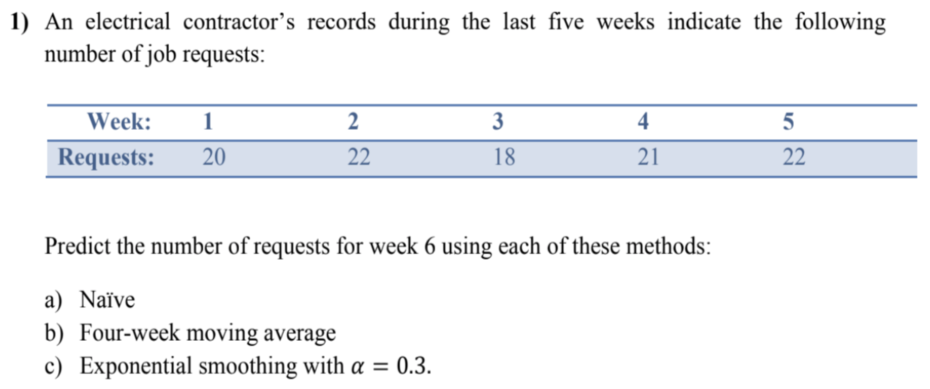

$22$

$\frac{22+18+21+22}{4}=20.75$

$F_{t}=F_{t-1}+α\left(A_{t-1}-F_{t-1}\right)$ $$F_{1}=20 \\ F_{2}=20+0.3\left(20-20\right)=20 \\ F_{3}=20+0.3\left(22-20\right)=20.6 \\ F_{4}=20.6+0.3\left(18-20.6\right)=19.82 \\ F_{5}=19.82+0.3\left(21-19.82\right)=20.17 \\ F_{6}=20.17+0.3\left(22-20.17\right)=20.72$$

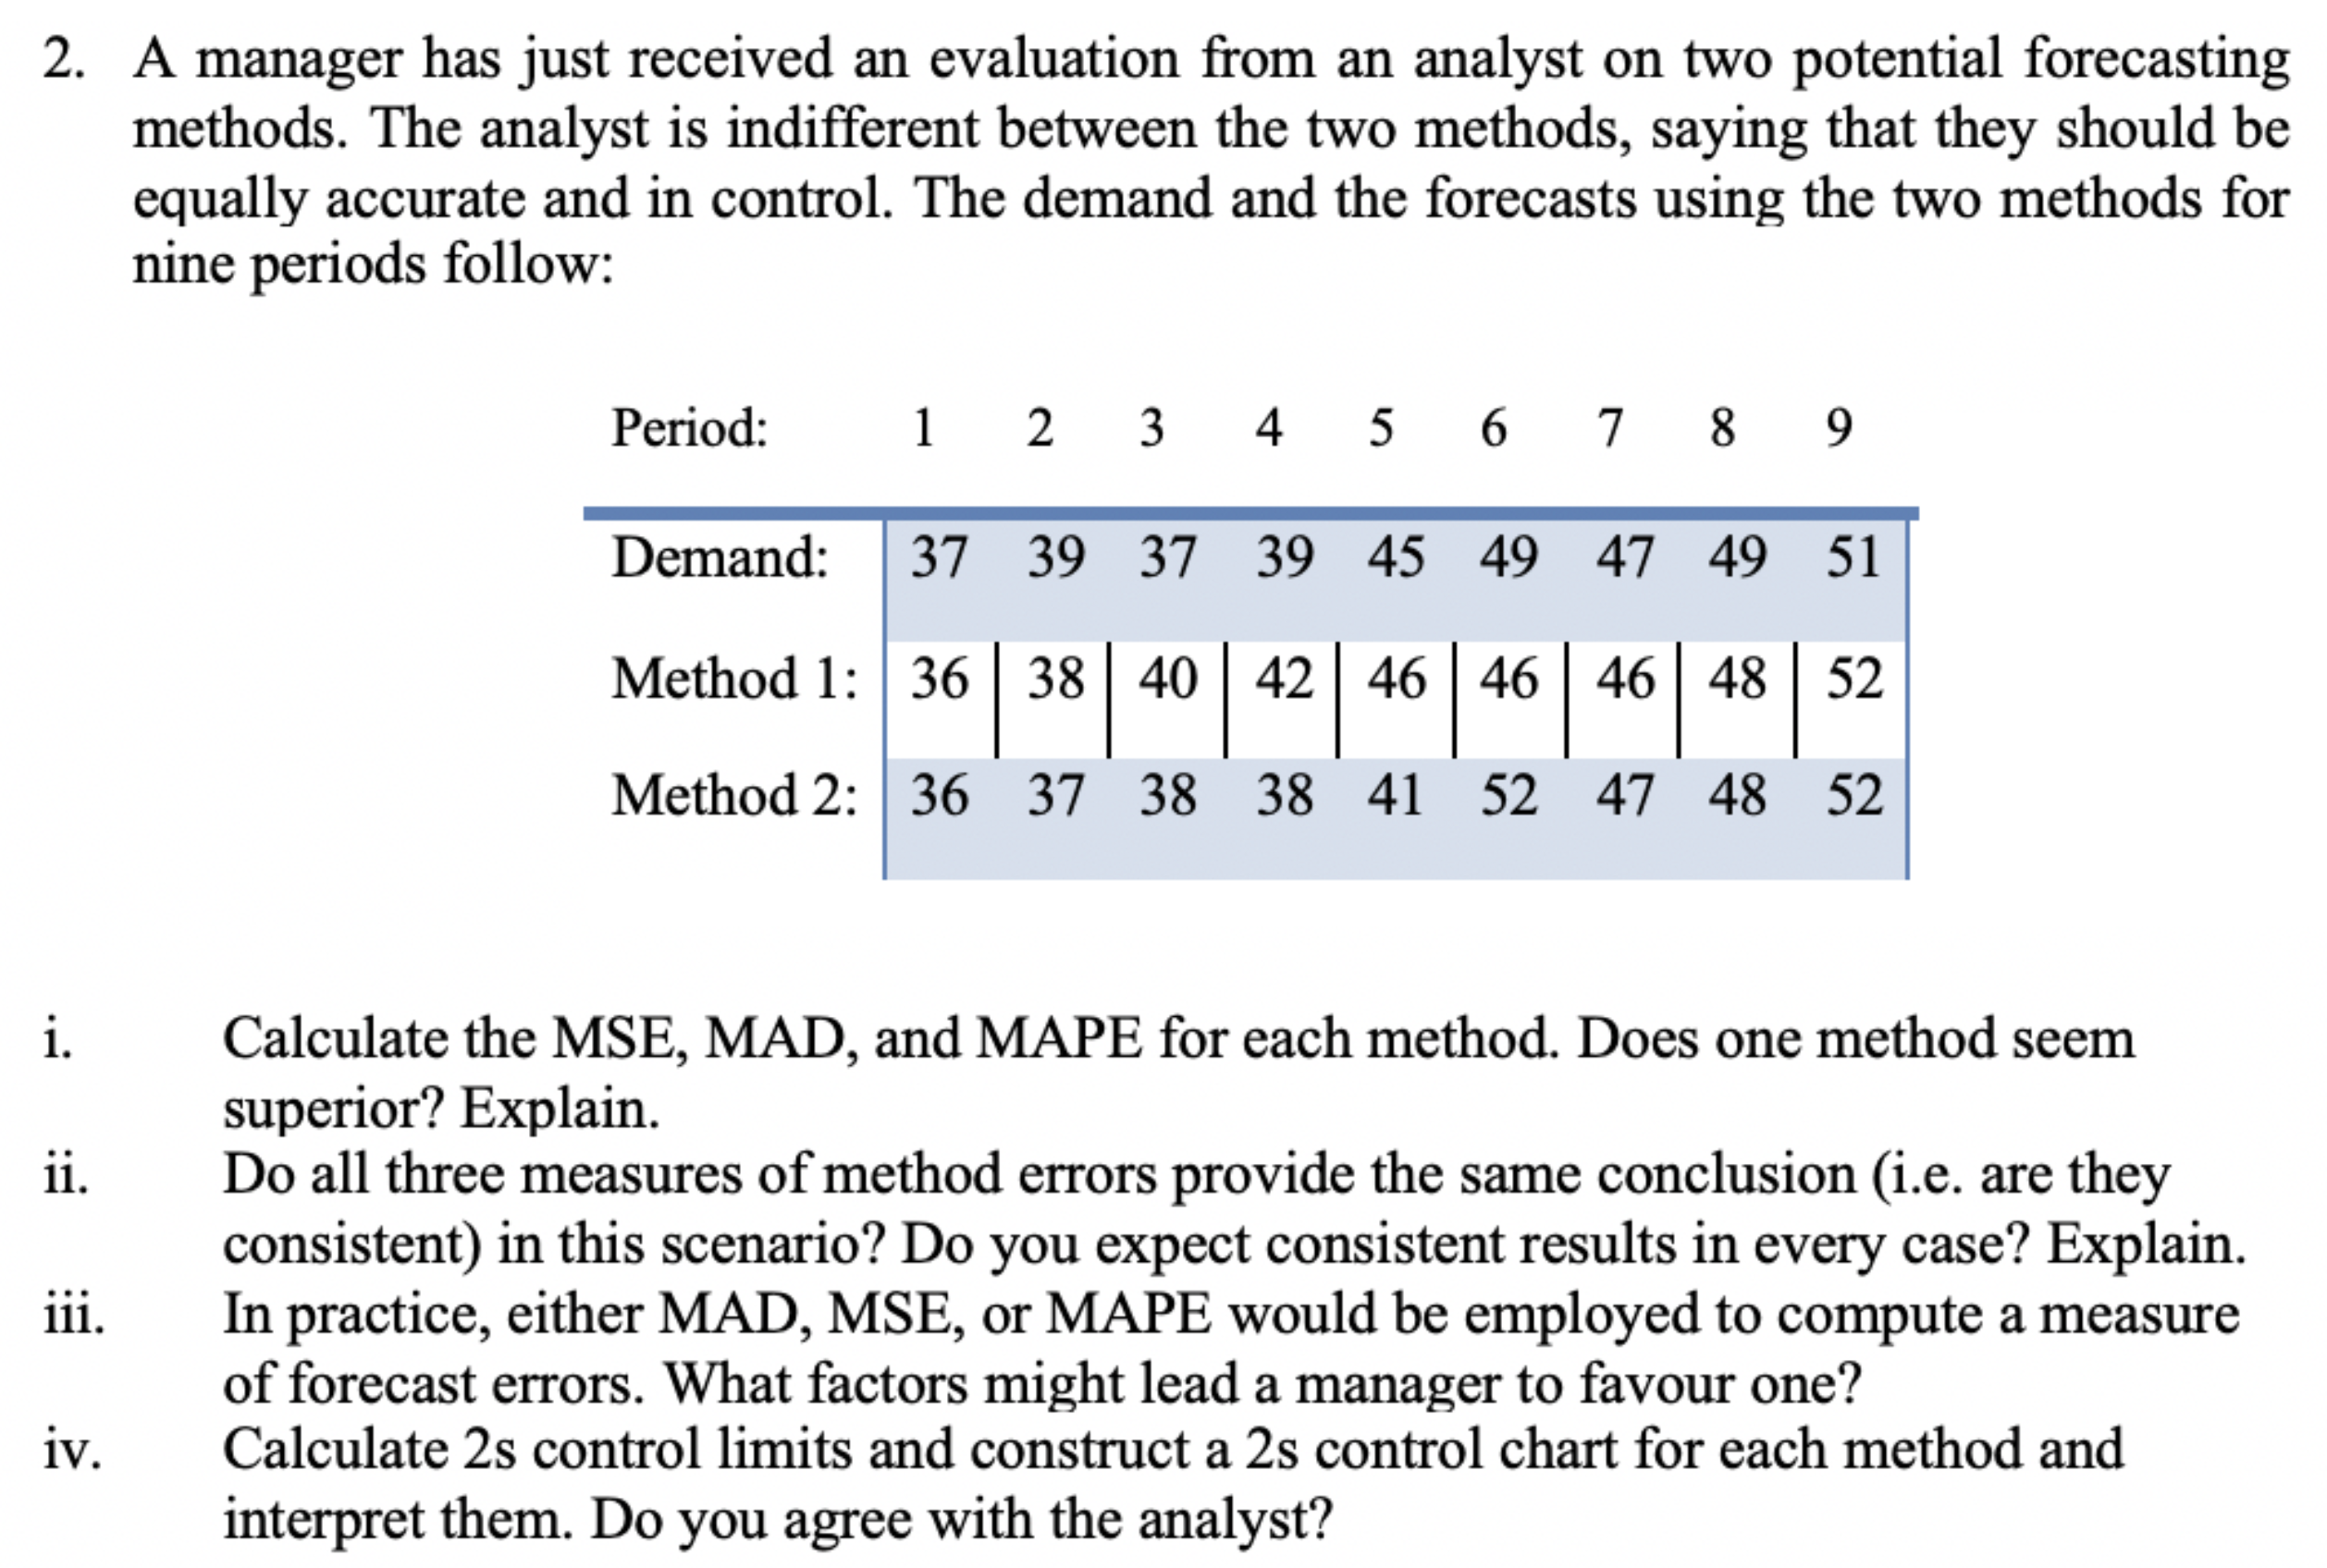

$MSE=\frac{∑{\left(A_{i}-F_{i}\right)}^{2}}{n}, MAD=\frac{∑\left|e\right|}{n}, MAPE=\frac{∑\left[\frac{\left|A_{i}-F_{i}\right|}{A_{i}}×100\right]}{n}$

|  |  |  |  |
| --- | --- | --- | --- |
| **Method** | **MSE** | **MAD** | **MAPE** |
| $$1$$ | $$3.7$$ | $$1.7$$ | 4.0 |
| $$2$$ | $$3.8$$ | $$16$$ | $$3.6$$ |

Both methods have similar $MSE, MAD, MAPE$, so neither is superior.

1. In this case, all calculations are similar, but may not be the same in other cases.
2. $MSE$ is more sensitive to large forecast errors, $MAD$ is easy to calculate, $MAPE$ is easy to understand.

$s_{1}=\sqrt{MSE_{1}}=\sqrt{3.7}=1.92, s_{2}=\sqrt{MSE_{2}}=\sqrt{3.78}=1.95$

Method 1: $2s$ control limits: $0±2s_{1}=0±2\left(1.92\right)⇒0±3.8$

Method 1: $2s$ control limits: $0±2s_{2}=0±2\left(1.95\right)⇒0±3.9$

Similar $2s$ control limits, however some errors outside limits.

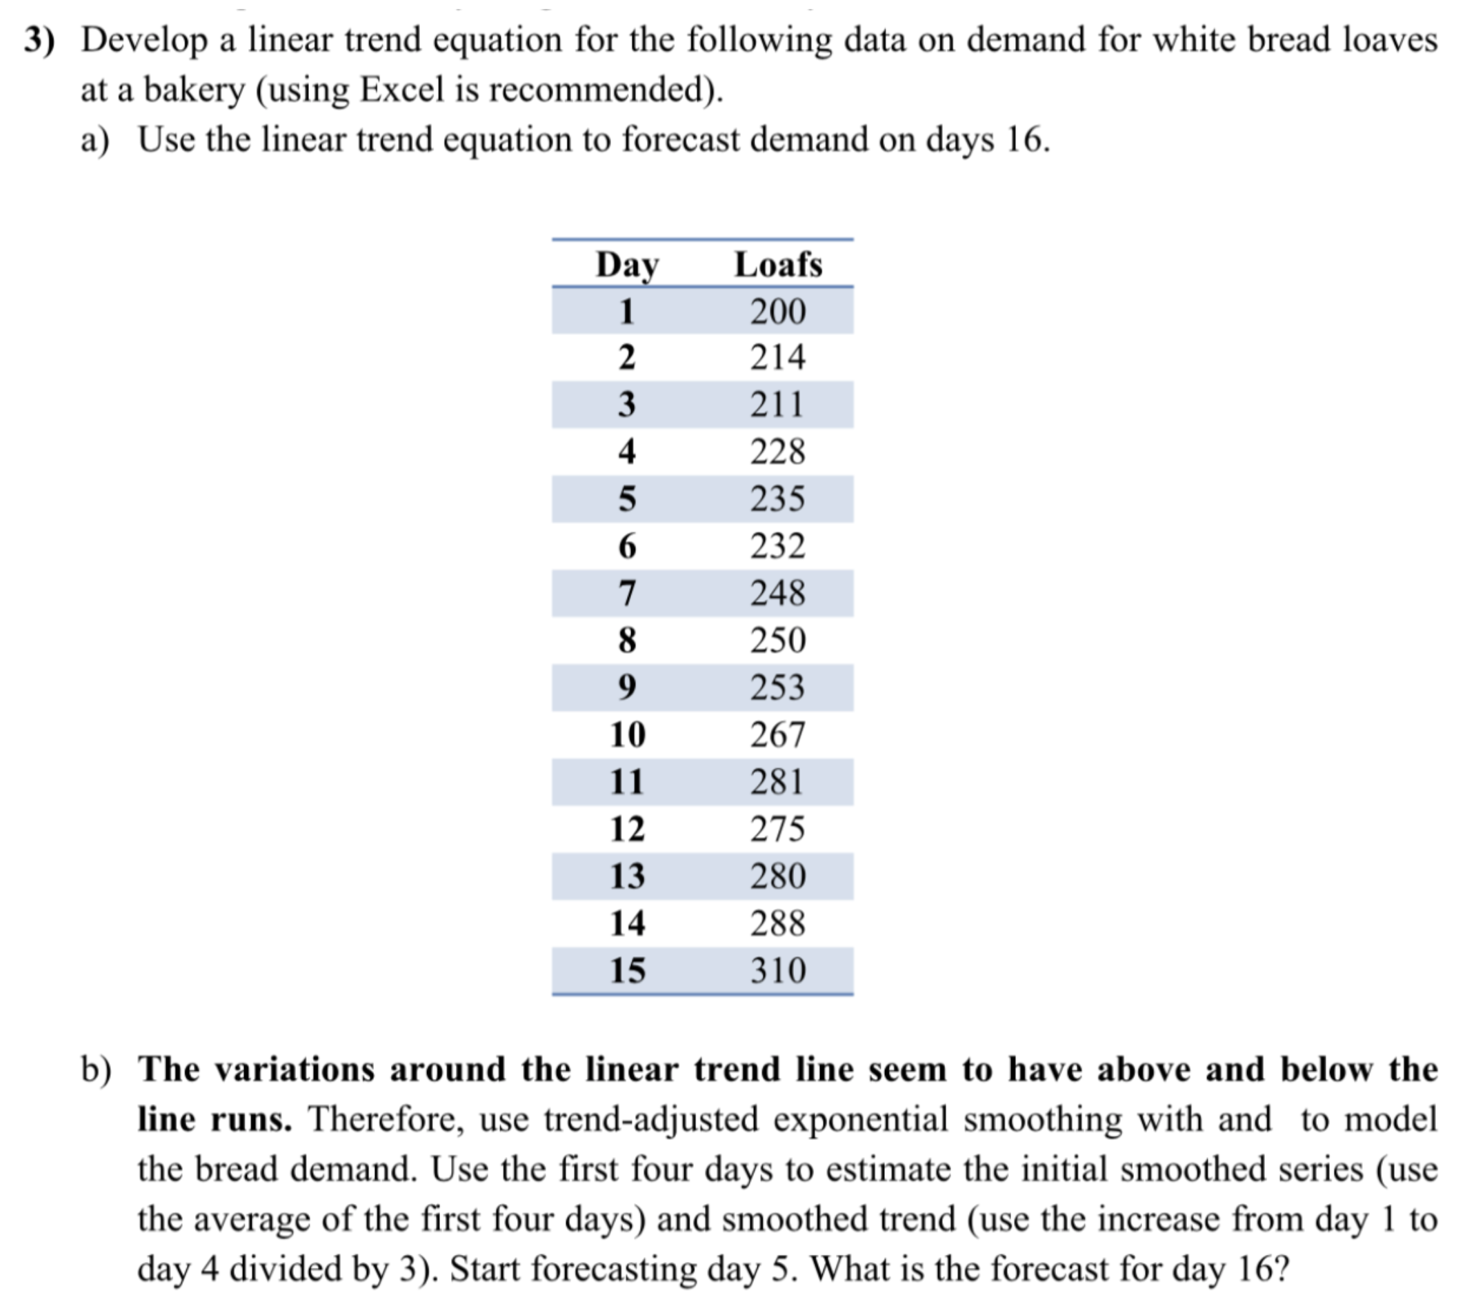

$α=0.3, β=0.2$

1. Equation of the trend: $y=7x+195.47$

$$D_{16}=7\left(16\right)+195.47⇒D_{16}=307.47$$

$S_{t}=TAF_{t}+α\left(A_{t}-TAF_{t}\right)$ $$T_{t}=T_{t-1}+β\left(S_{t}-S_{t-1}-T_{t-1}\right) \\ TAF_{t+1}=S_{t}+T_{t}$$

$$T_{4}=\frac{228-200}{3}=9.33, S_{4}=\frac{200+214+211+228}{4}=213.25$$
2. ­

Use above equations each time to get $TAF_{16}=S_{15}+T_{15}=303.53+7.64=311.17$.

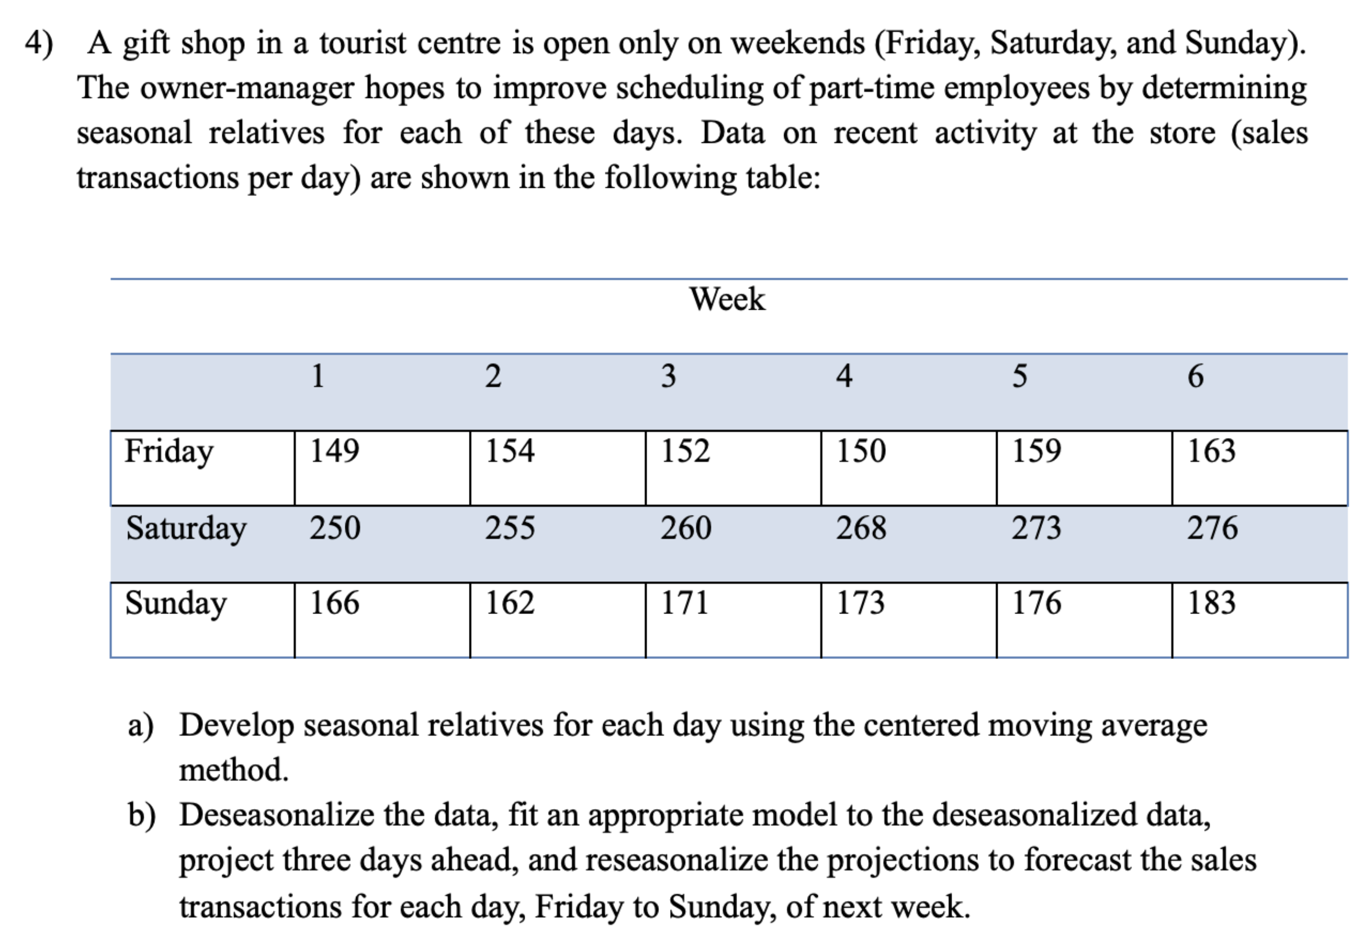

1. Seasonal relatives are shown as the values in the $adjusted$ row:

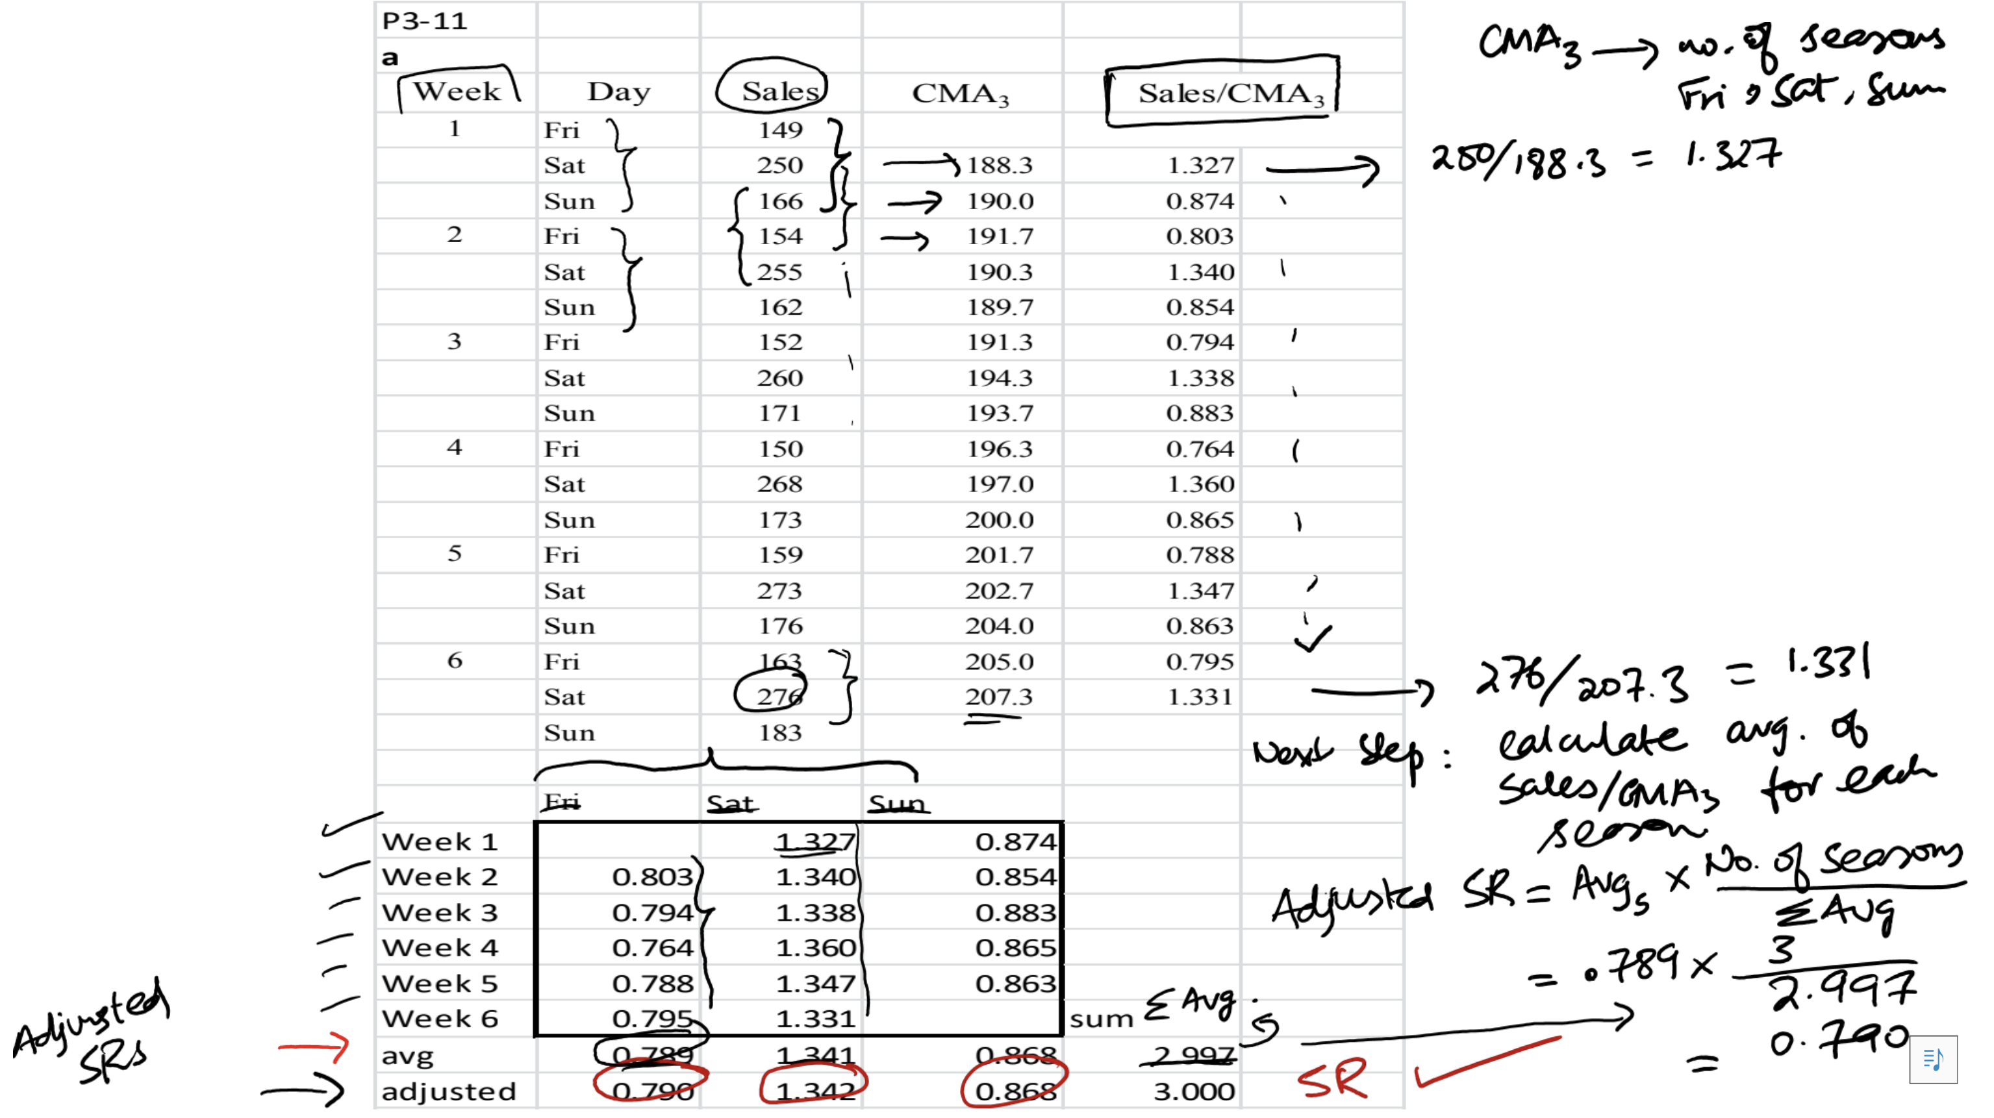

1. Deseasonalized data is shown as the values in the $Sales/SR$ column:

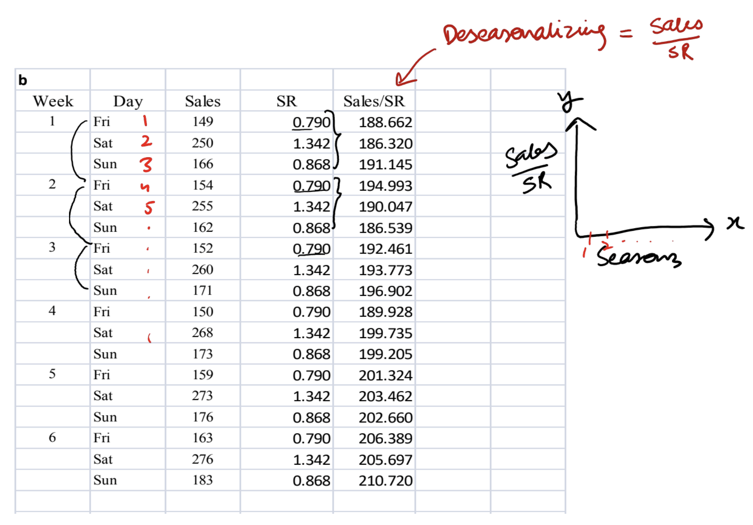

The model, projection, and reseasonalized data is shown below:

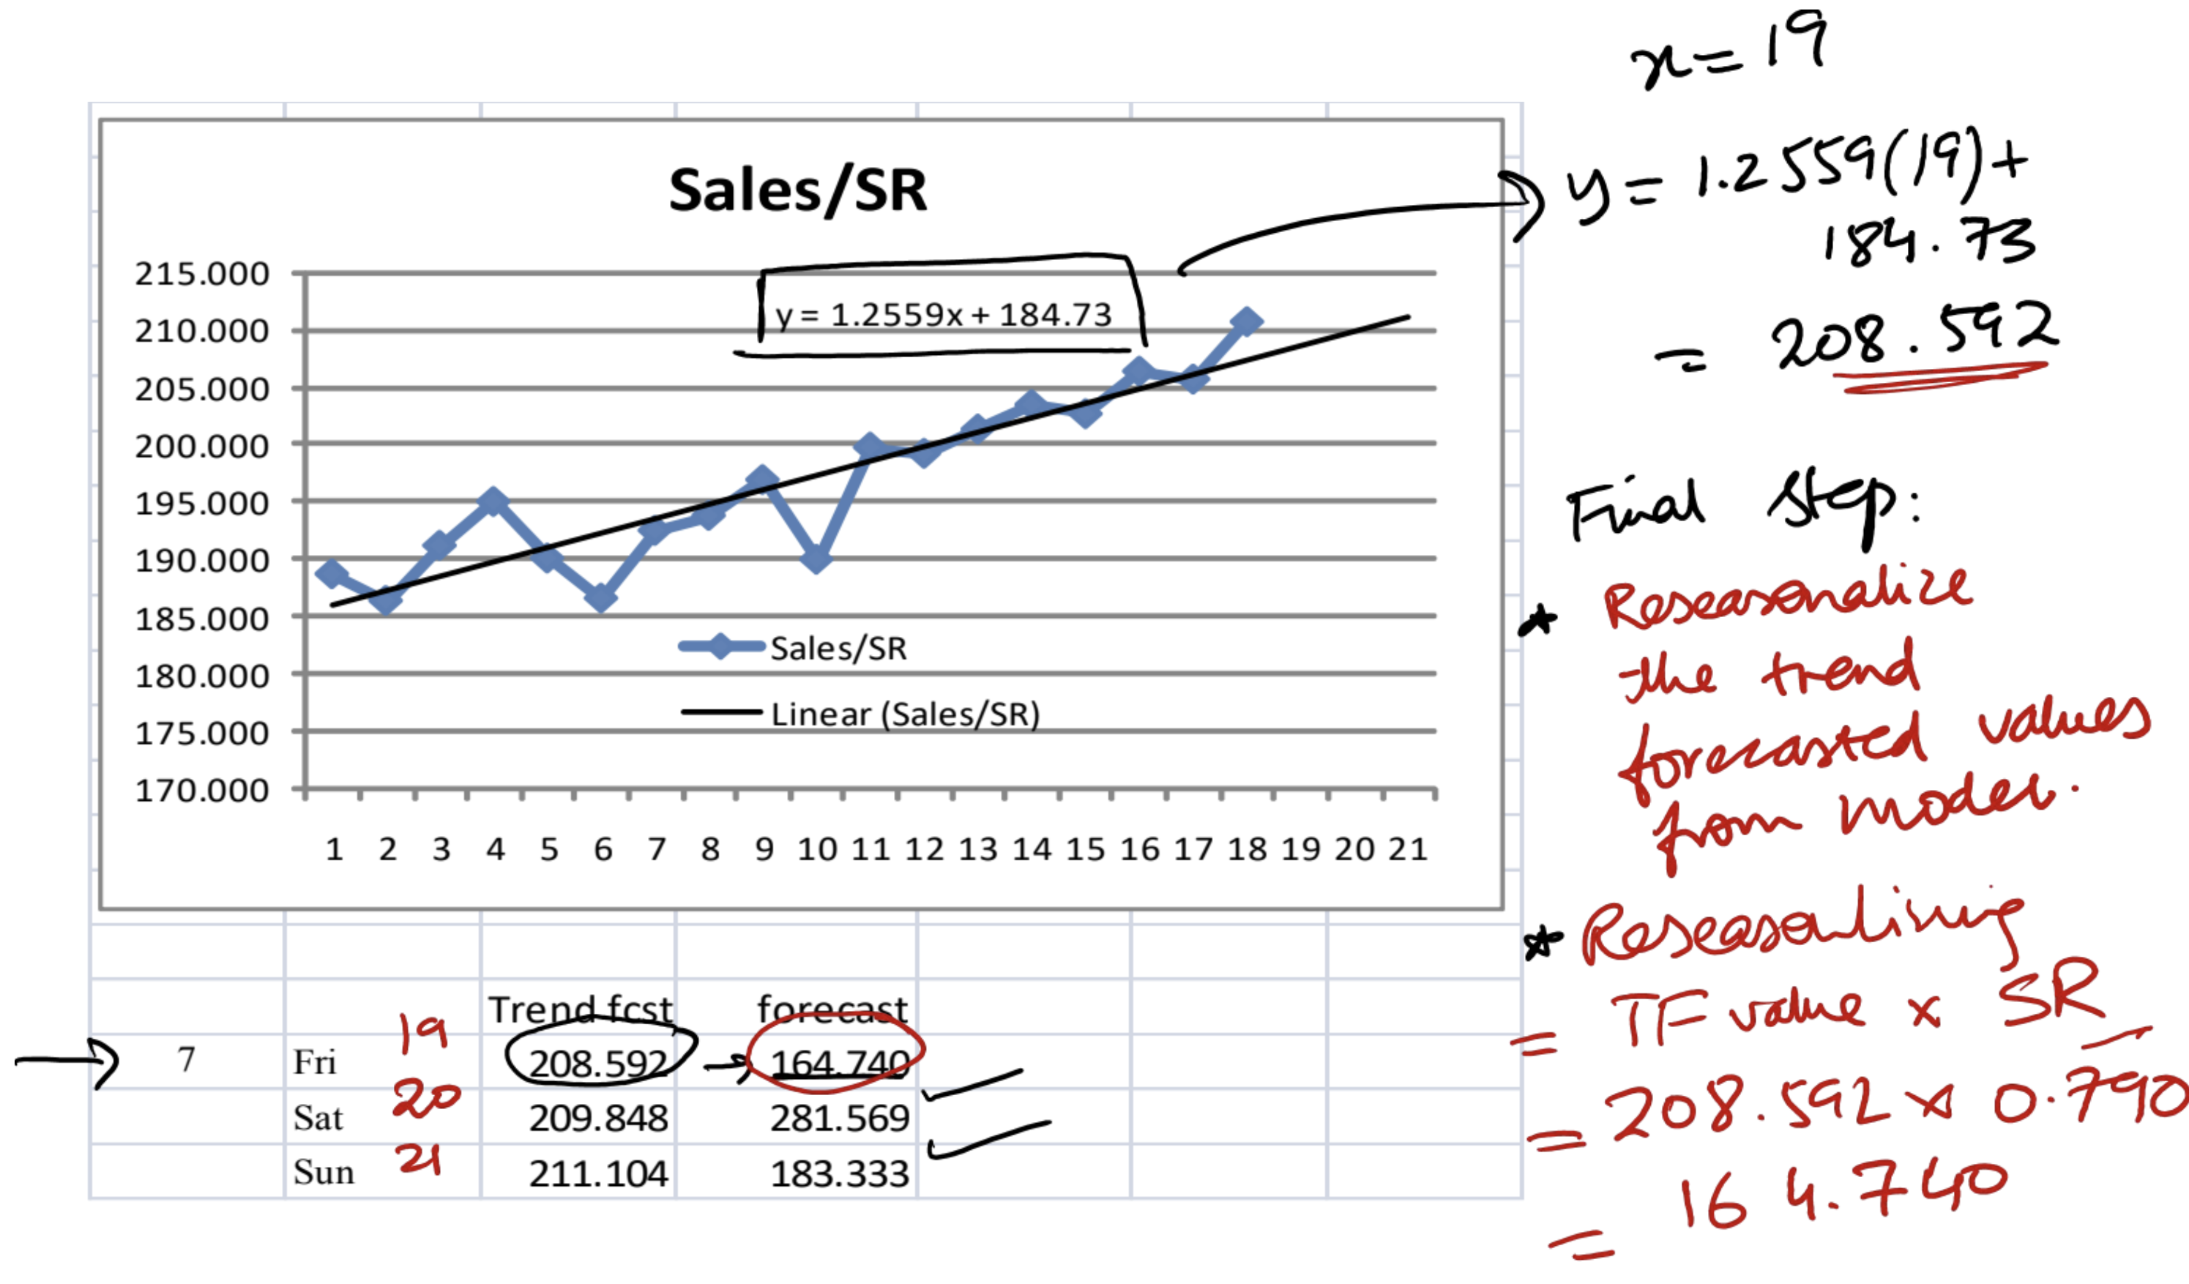

# Tutorial 2: Capacity Planning and Facility Layout

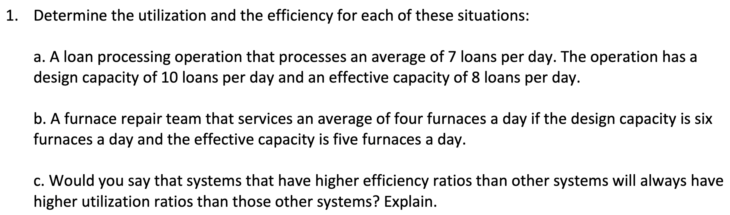

$actual output=7, design capacity=10, effective capacity=8$ $$utilization=\frac{actual output}{design capacity}=\frac{7}{10}=70\% \\ efficiency=\frac{actual output}{effective capacity}=\frac{7}{8}=87.5\%$$

$actual output=4, design capacity=6, effective capacity=5$ $$utilization=\frac{actual output}{design capacity}=\frac{4}{6}=66\% \\ efficiency=\frac{actual output}{effective capacity}=\frac{4}{5}=80\%$$

1. No because utilization depends on design capacity while efficiency depends on effective capacity.

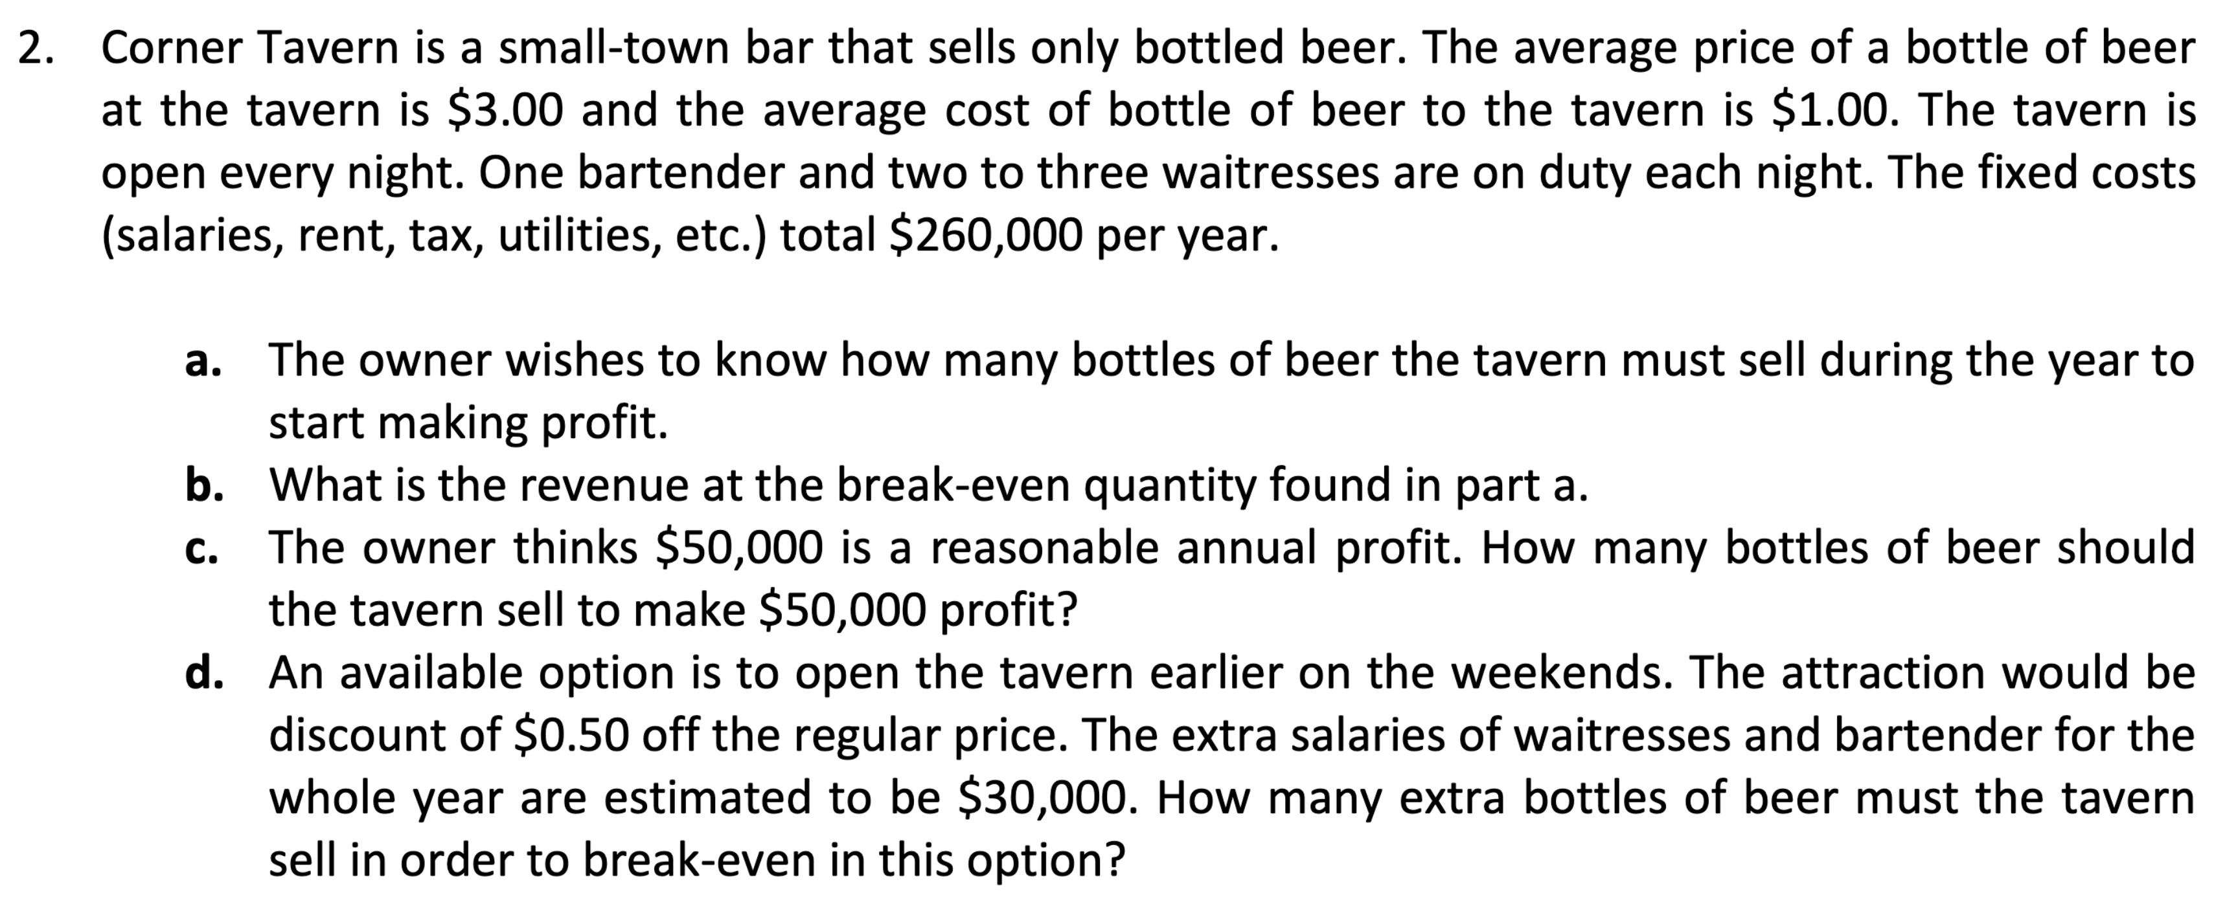

$average price \left(R\right)=\$3.00, average cost \left(v\right)=\$1.00, fixed cost \left(FC\right)=\$260,000$ $$Q_{BEP}=\frac{FC}{R-v}=\frac{260,000}{3-1}=130,000 bottles$$

$TR_{BEP}=Q_{BEP}⋅R=130,000⋅3=\$390,000$

$Q=\frac{P+FC}{R-v}=\frac{50,000+260,000}{3-1}=155,000 bottles$

$Q_{BEP}^{'}=\frac{FC^{'}}{R^{'}-v}=\frac{30,000}{2.5-1}=20,000 bottles$

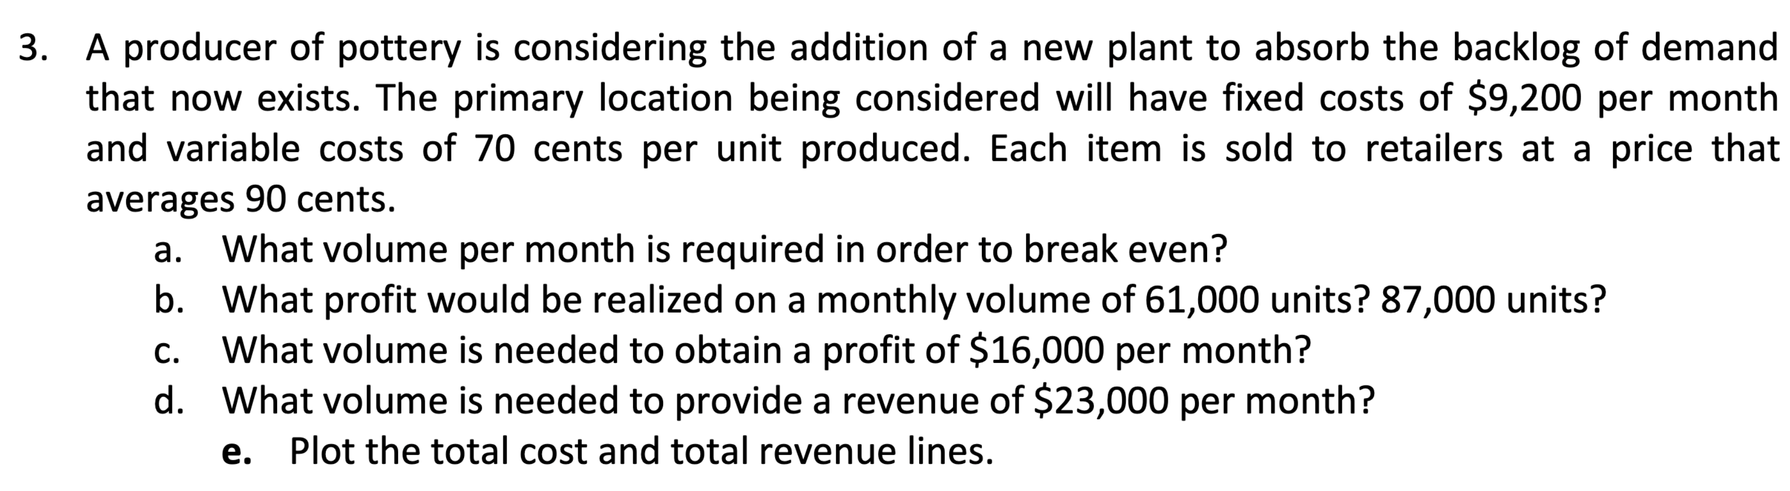

$FC=\$9,200, v=70 cents→\$0.7, R=90 cents→\$0.9$ $$Q_{BEP}=\frac{FC}{R-v}=\frac{9,200}{0.9-0.7}=46,000 units$$

$P=Q\left(R-v\right)-FC$ $$P_{1}=61,000\left(0.9-0.7\right)-9,200=\$3,000$$

$$P_{2}=87,000\left(0.9-0.7\right)-9,200=\$8,200$$

$Q=\frac{P+FC}{R-v}=\frac{16,000+9,200}{0.9-0.7}=126,000 units$

$Q=\frac{P+FC}{R-v}=\frac{23,000+9,200}{0.9-0.7}=161,000 units$

1. Plot of $total cost (TC)=0.7Q+10,000$ and $total revenue (TR)=0.9Q$ lines:

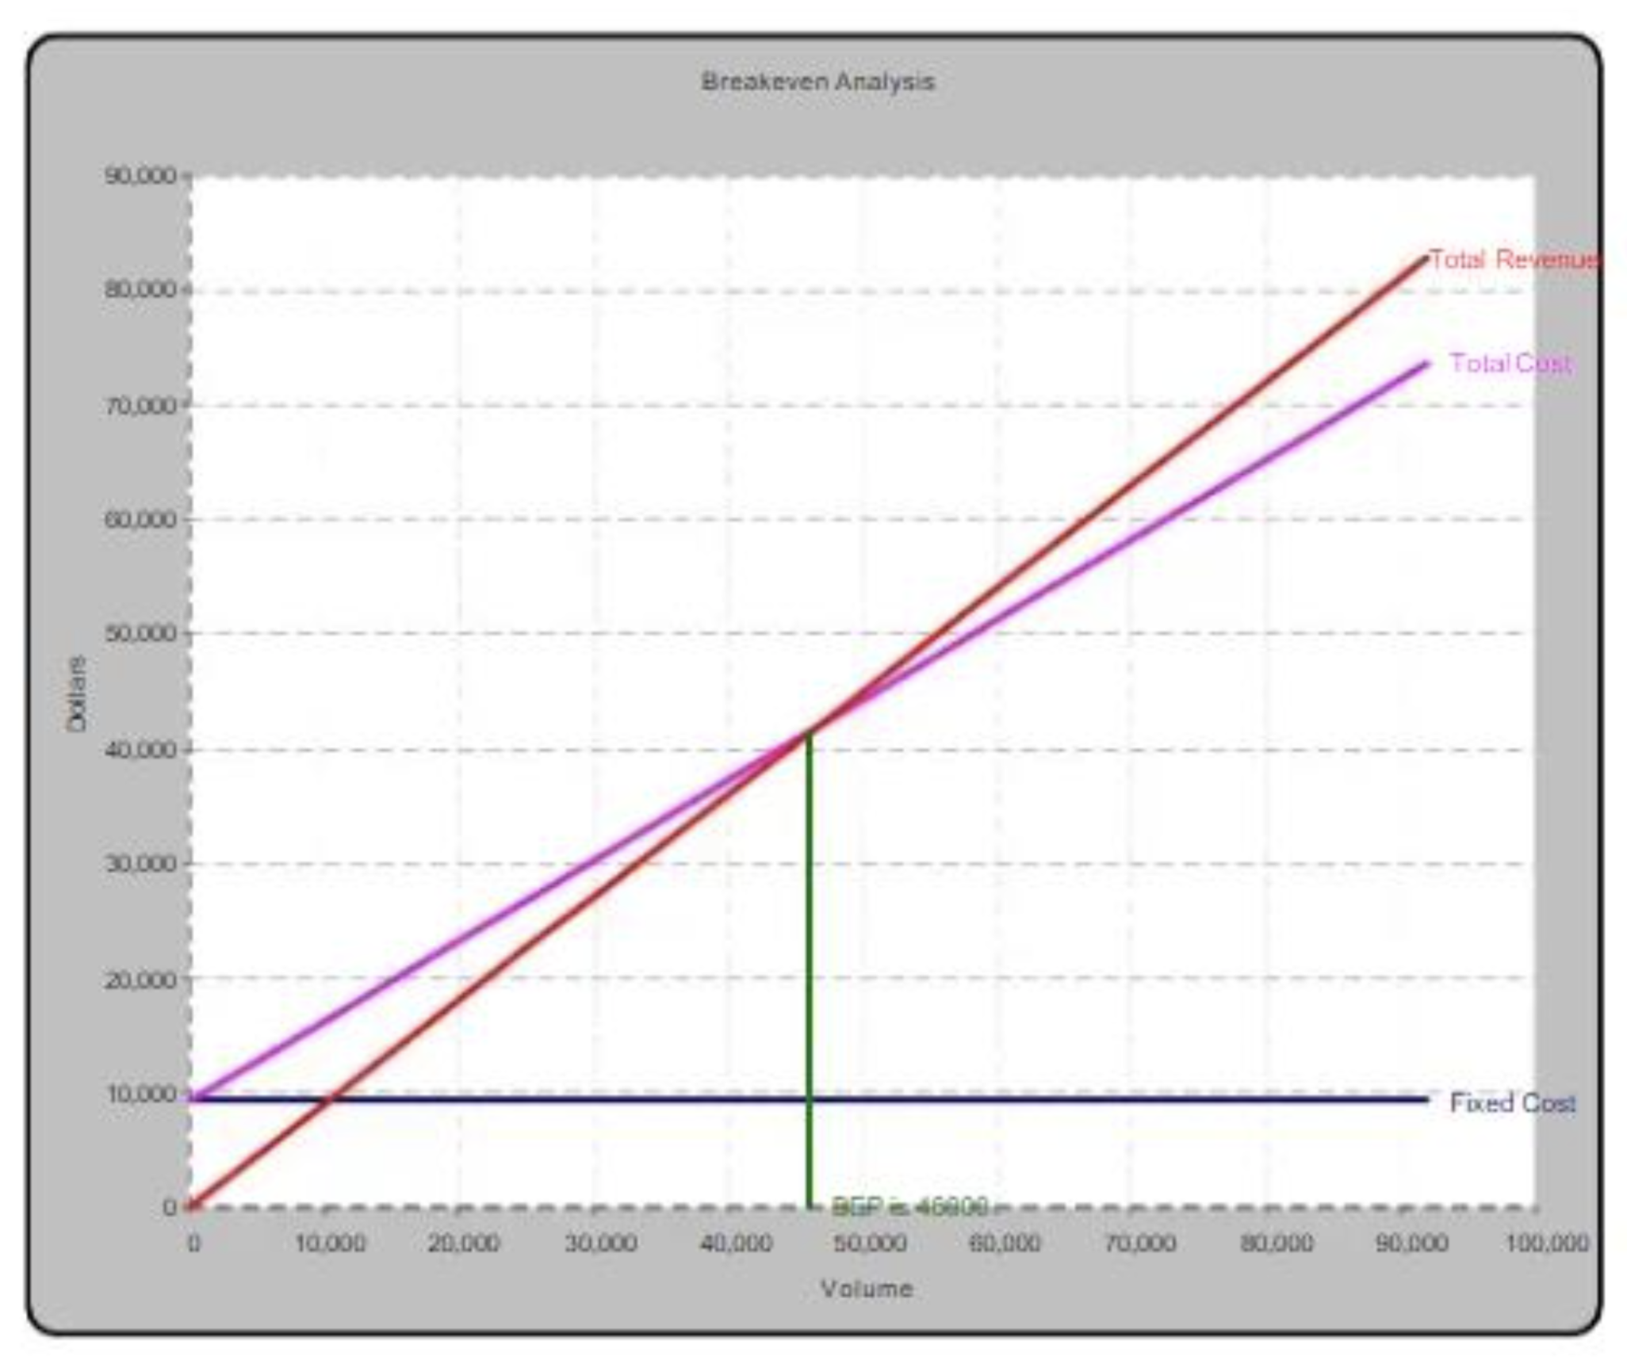

# Tutorial 3: Process Design and Facility Layout

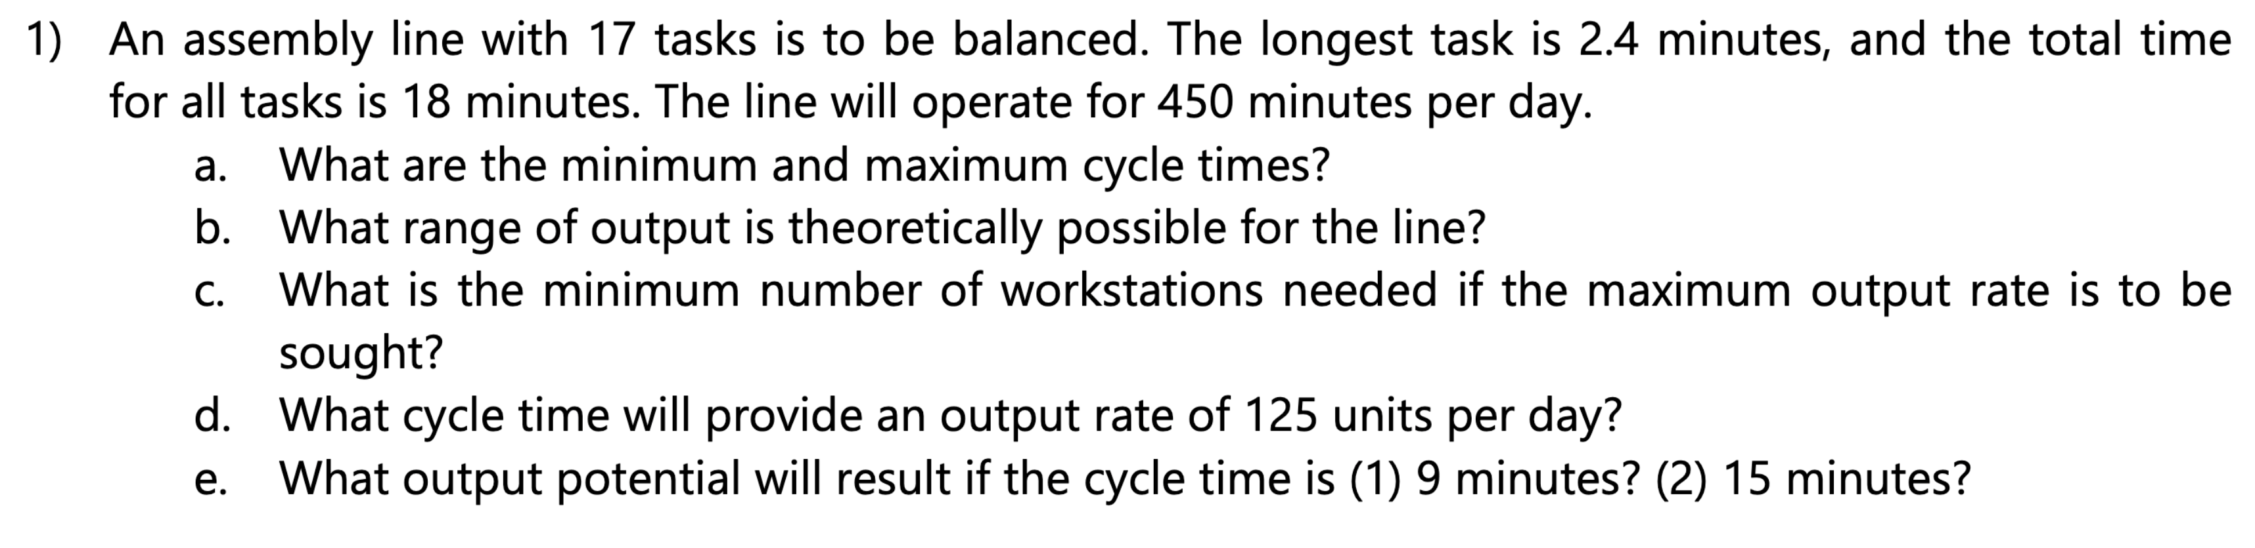

$OT=450 minutes$

$Minimum cycle time=length of longest task=2.4 minutes$

$Maximum cycle time=\sum{task times}=18 minutes$

$At 2.4 min:\frac{450}{2.4}=187.5 units$

$At 18 min:\frac{450}{18}=25 units$

$N=\frac{D×\sum{t}}{OT}=\frac{187.5×18}{450}=7.5→8$

1. $Output=\frac{OT}{CT}$, Solving for $CT$: $CT=\frac{450}{125}=3.6 minutes/cycle$
2. Potential output:

$\left(1\right) CT=9 min→\frac{OT}{CT}=\frac{450}{9}=50 units$

$\left(2\right) CT=15 min→\frac{450}{15}=30 units$

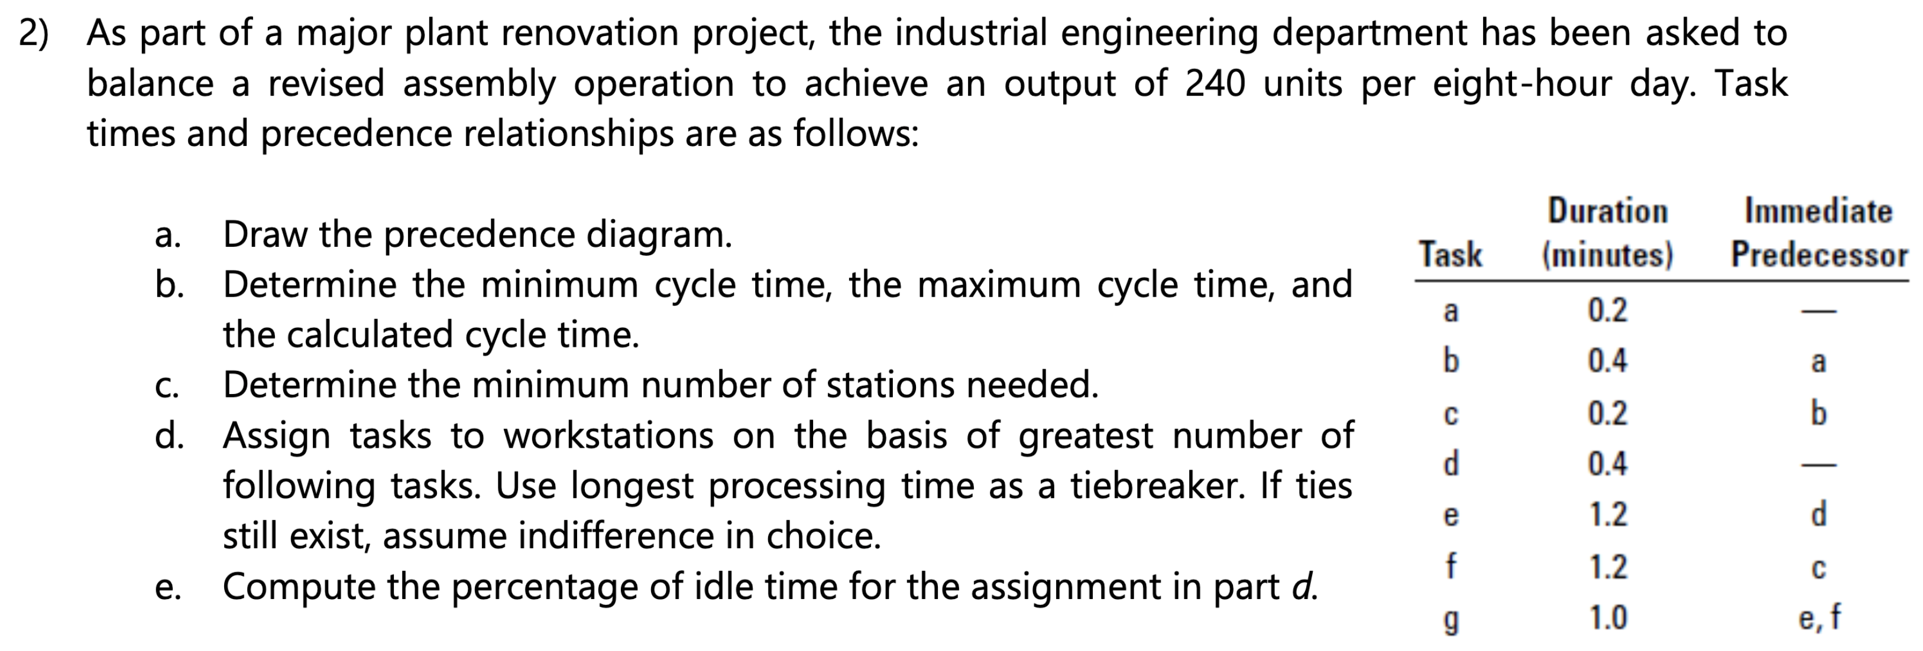

1. Precedence diagram:

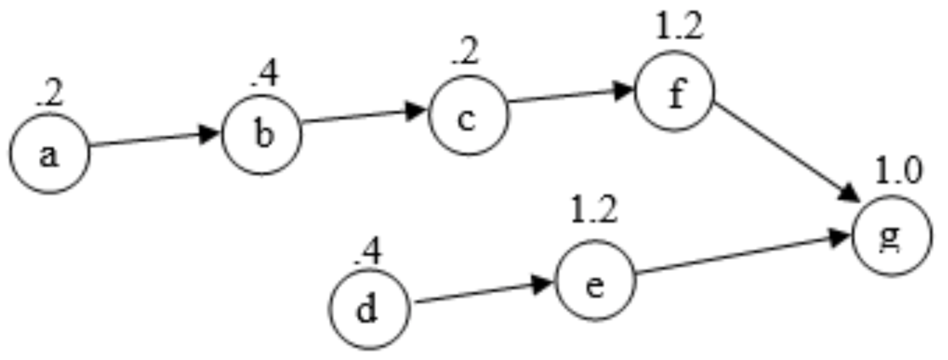

$Minimum cycle time=maximum task time=1.2 minutes$

$Maximum cycle time=0.2+0.4+0.2+0.4+1.2+1.2+1.0=4.6 minutes$

$CT=\frac{OT}{output}=\frac{480 min/day}{240 units/day}=2 minutes$

$N=\frac{\sum{t}}{CT}=\frac{4.6}{2.0}=2.3→3 stations$

1. Assign tasks to workstations:

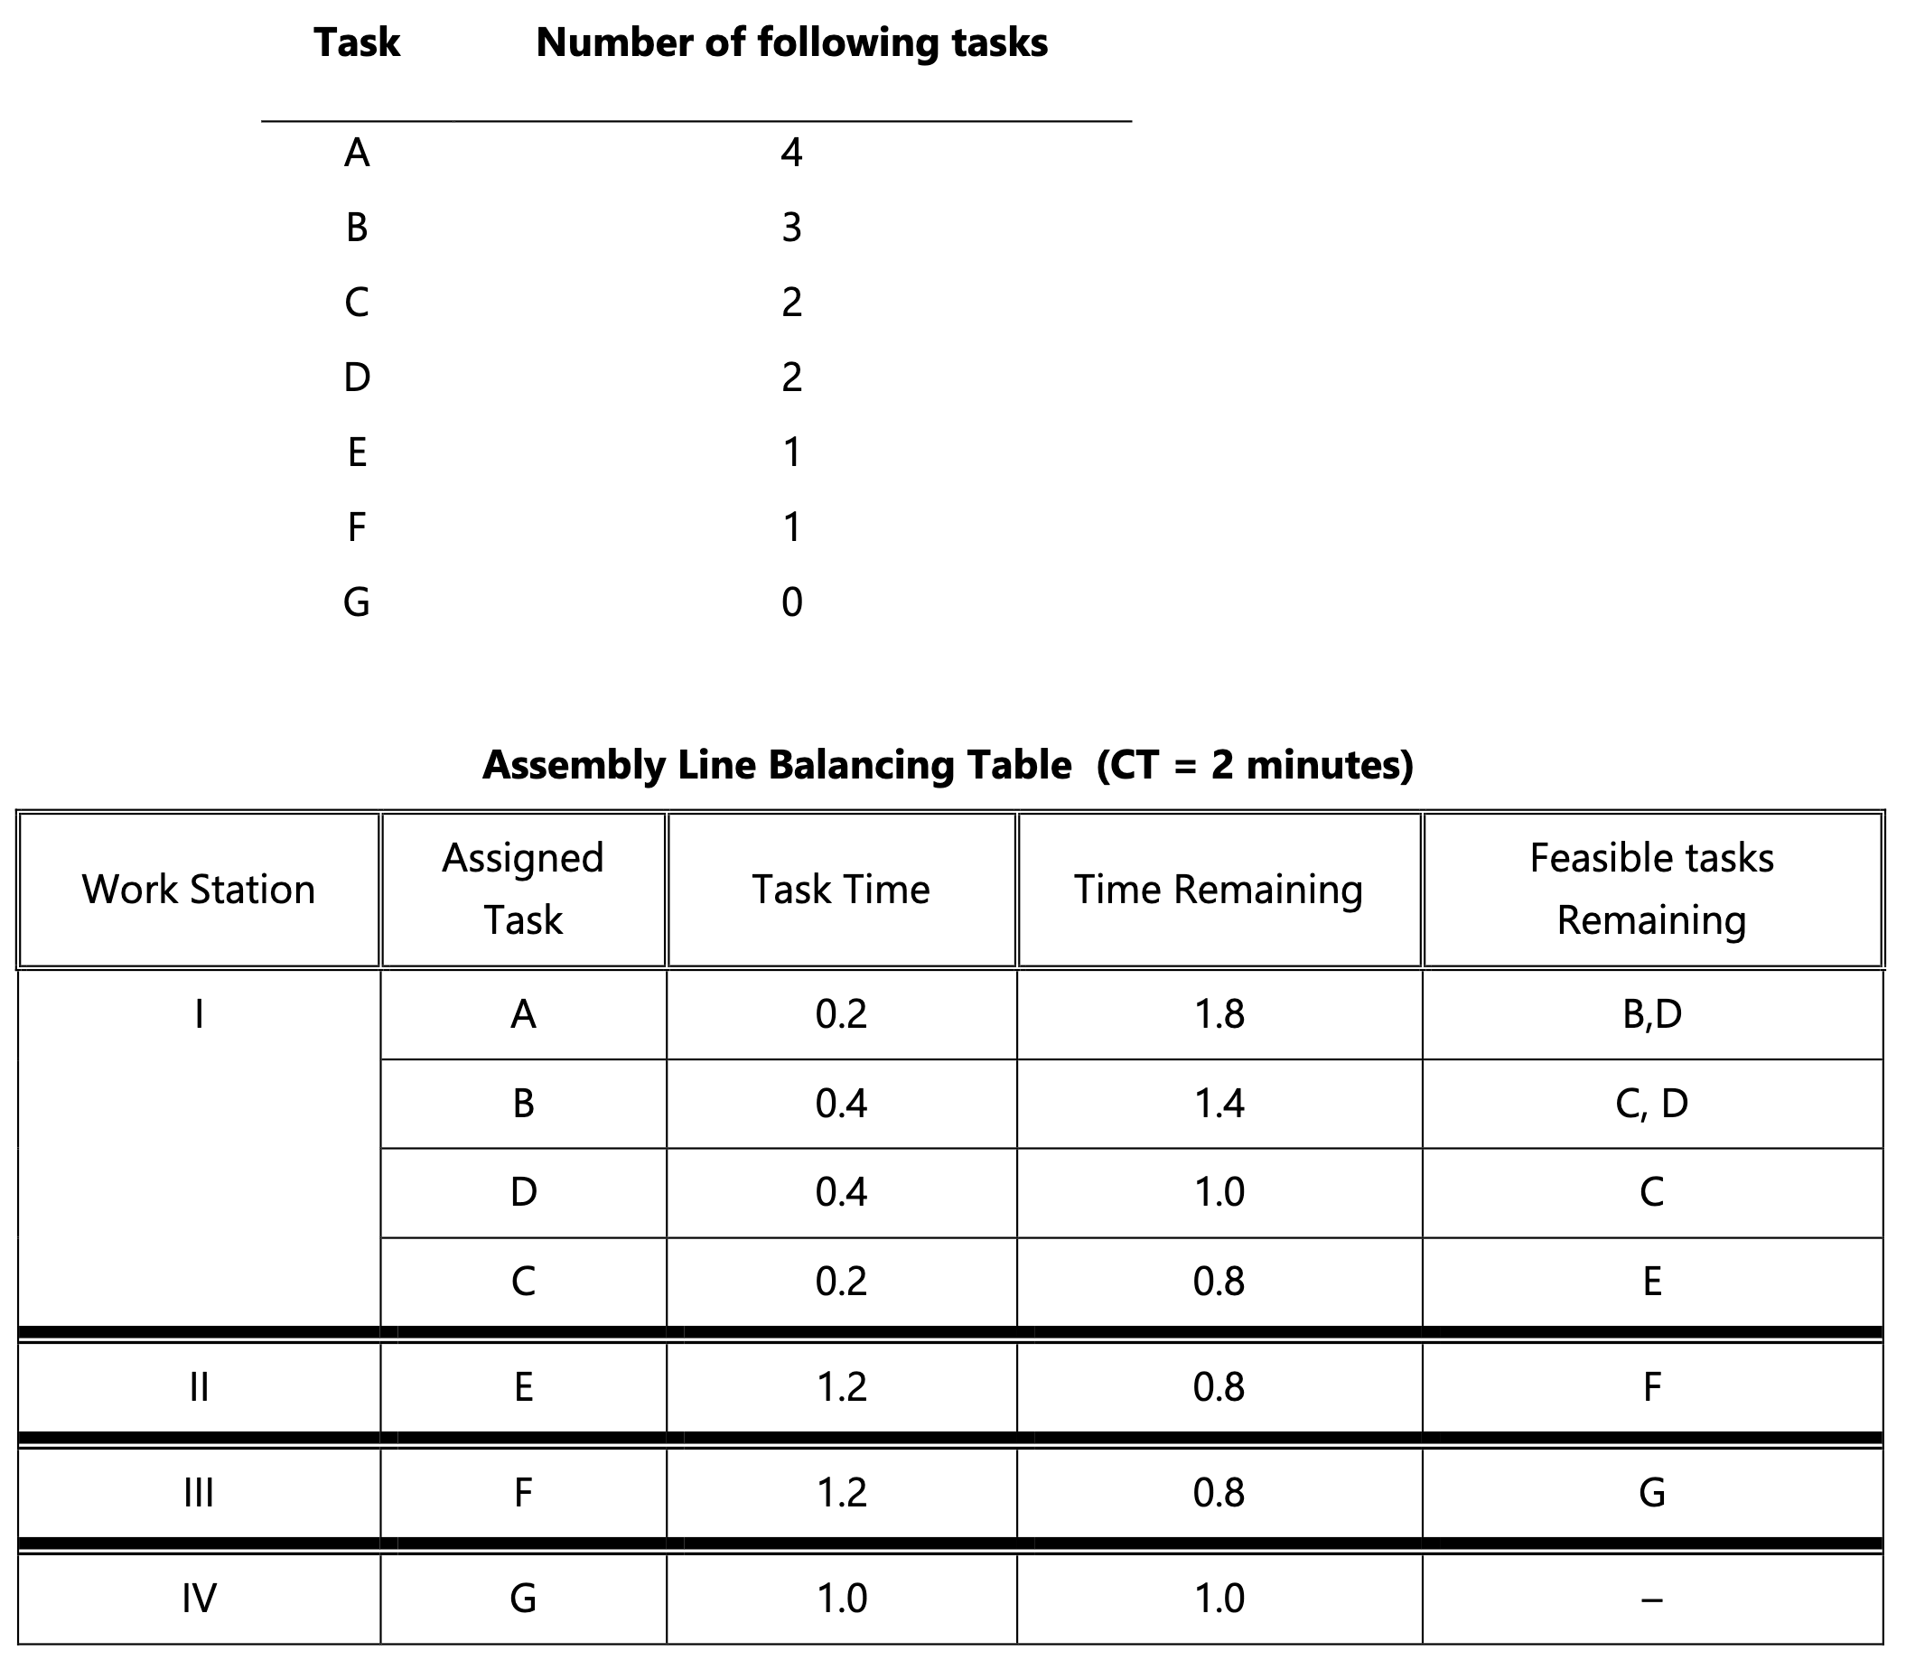

$Idle percent=\frac{0.8+0.8+0.8+1.0}{\left(4\right)\left(2\right)}=\frac{3.4}{8.0}=42.5\%$

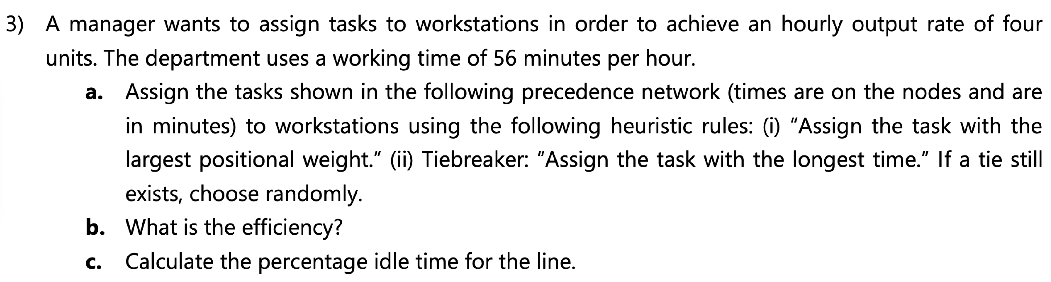

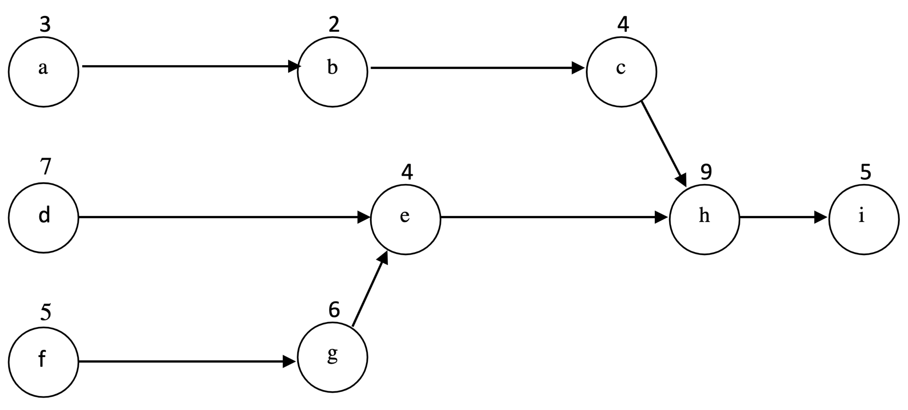

$Desired output=4 units/hour$

$Operating time=56 minutes/hour$

$CT=\frac{Operating time}{Desired output}=\frac{56 minutes/hour}{4 units/hour}=14 minutes/unit$

$N_{min}=\frac{\sum{t}}{CT}=\frac{3+2+4+7+4+5+6+9+5}{14}=3.21→4 workstations$

Positional weights:

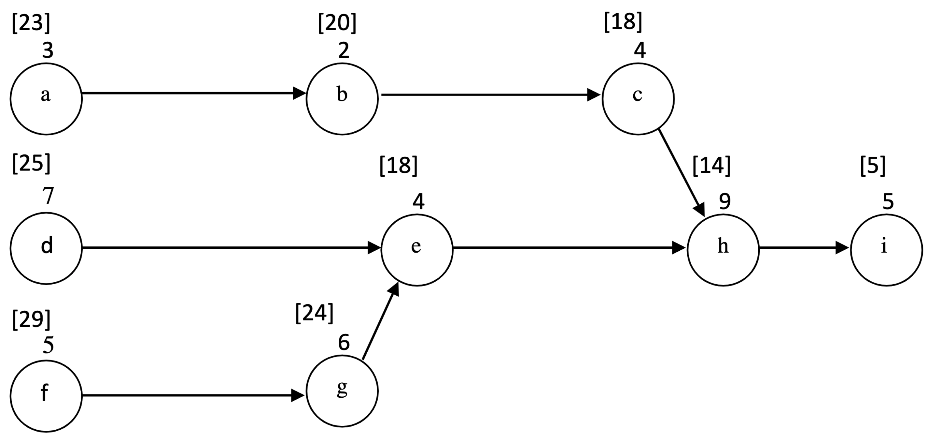

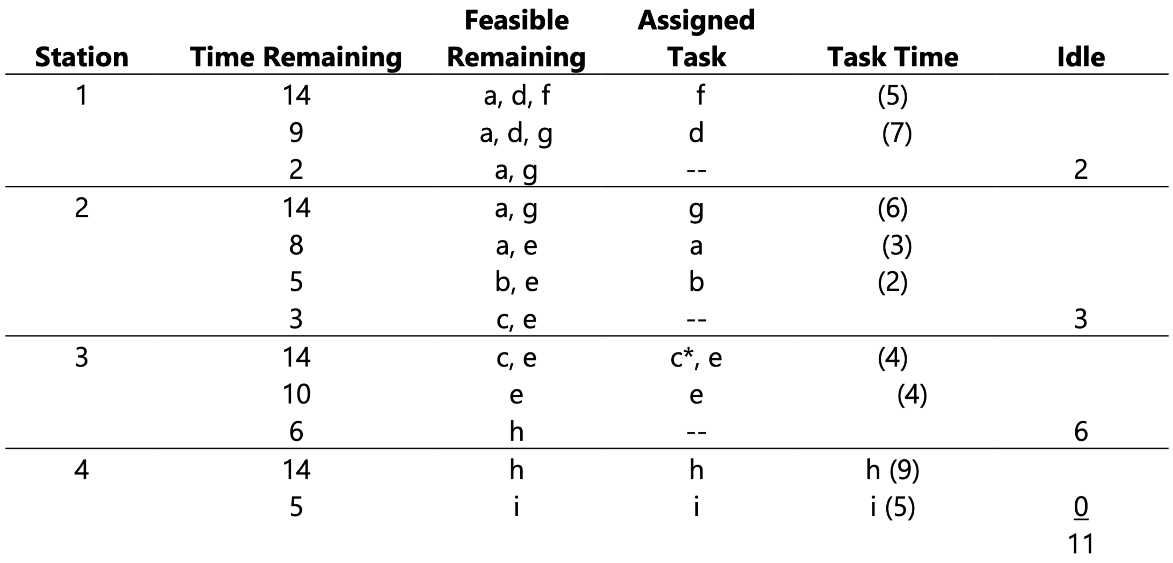

4. Fixed-Position Layout: Product or project remains stationary, and workers, materials, and equipment are moved as needed.

5. Cycle Time: The maximum time allowed at each workstation to complete its set of tasks on a unit.

# Tutorial 4: Quality Management and Statistical Control

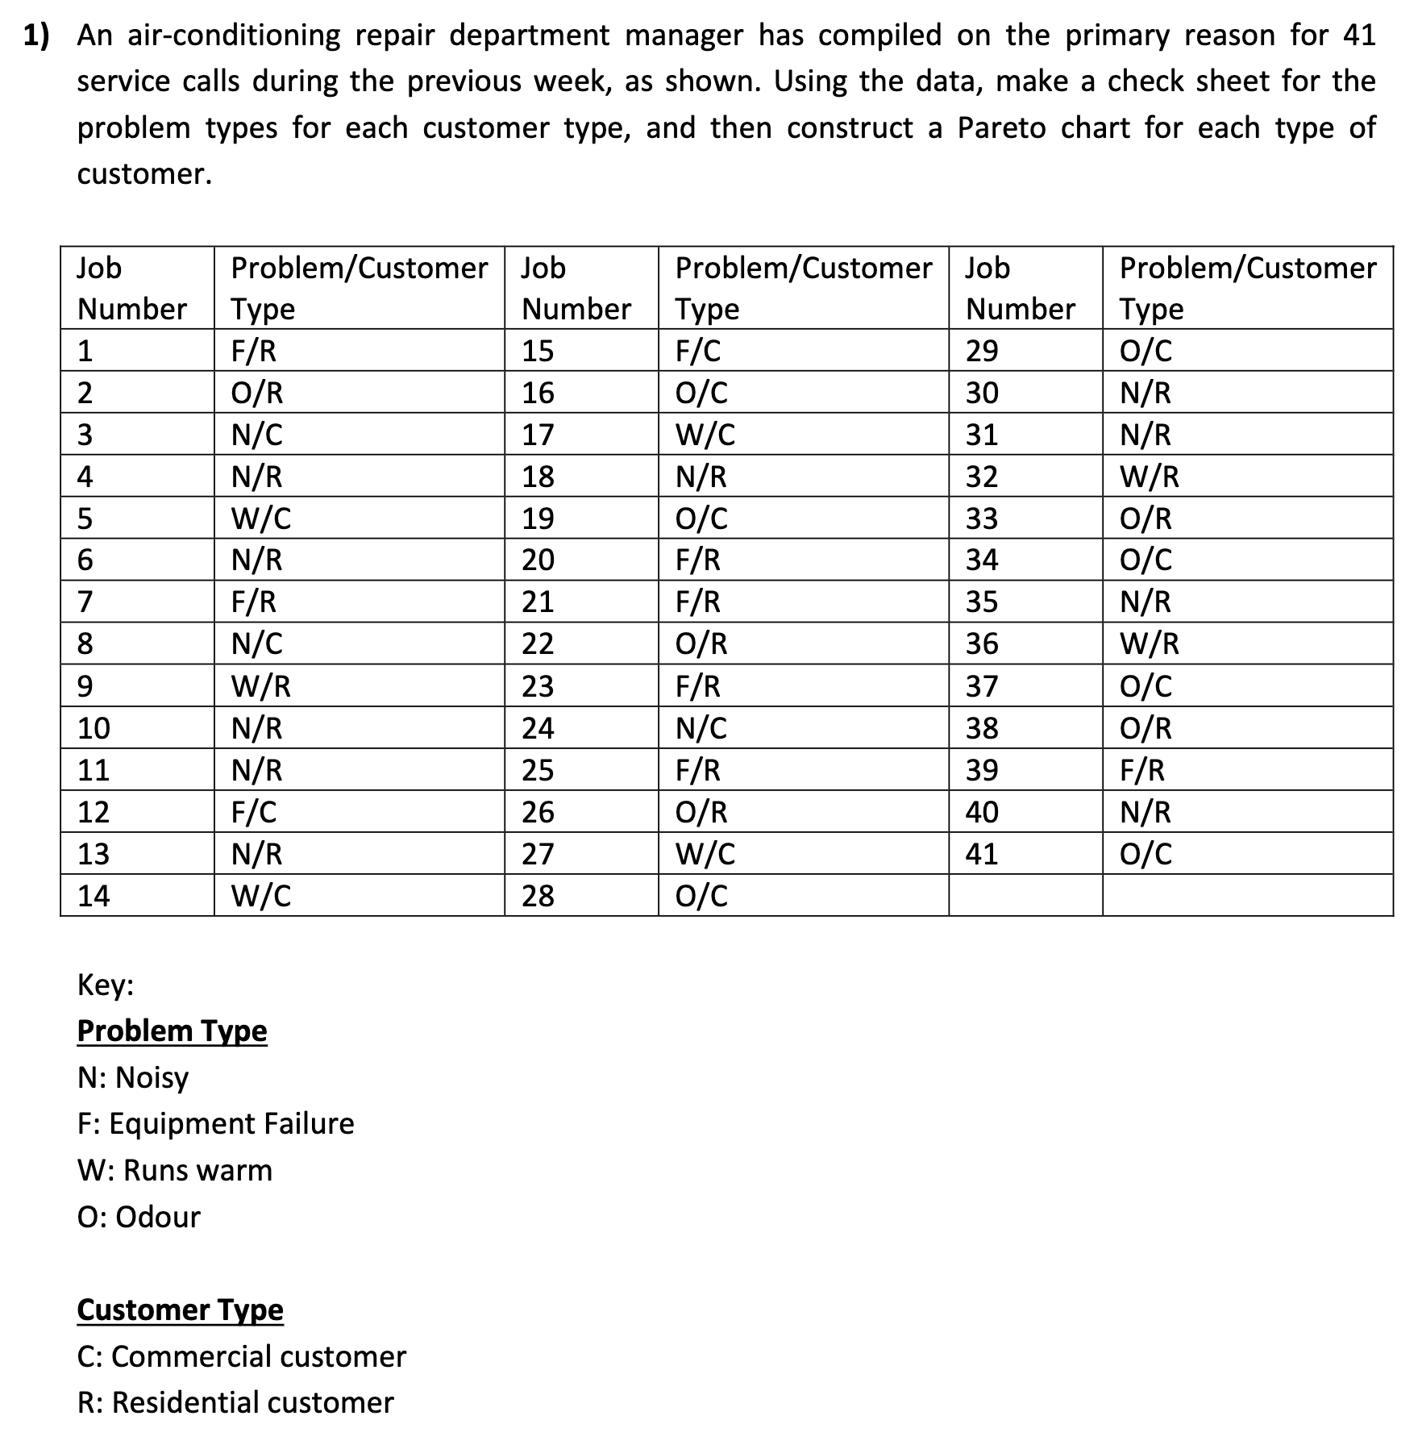

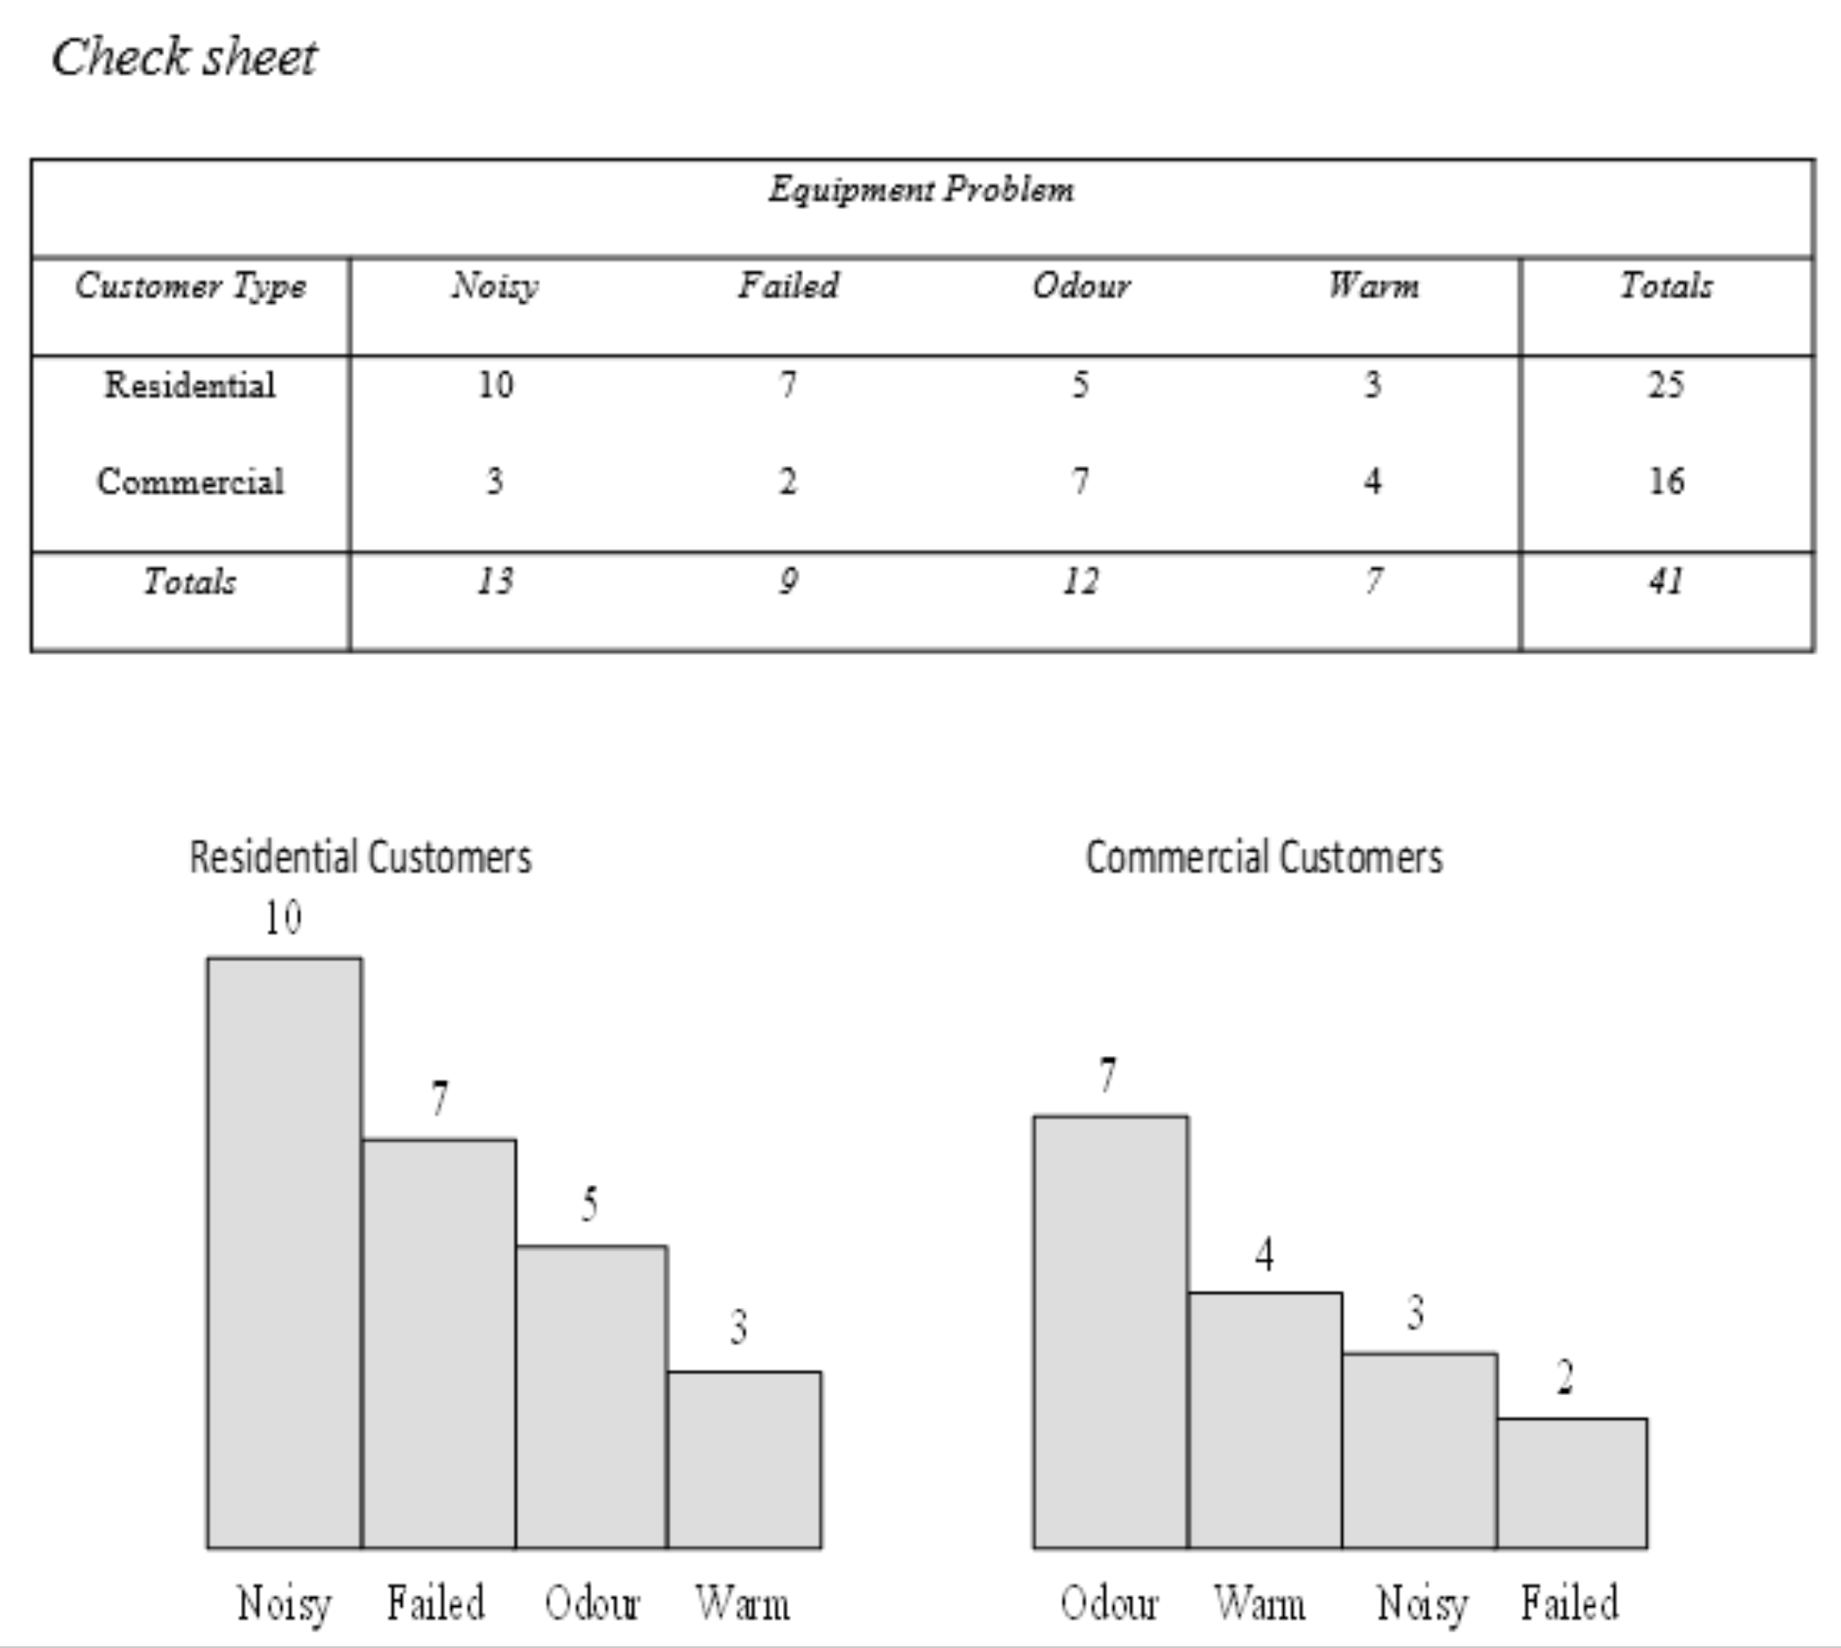

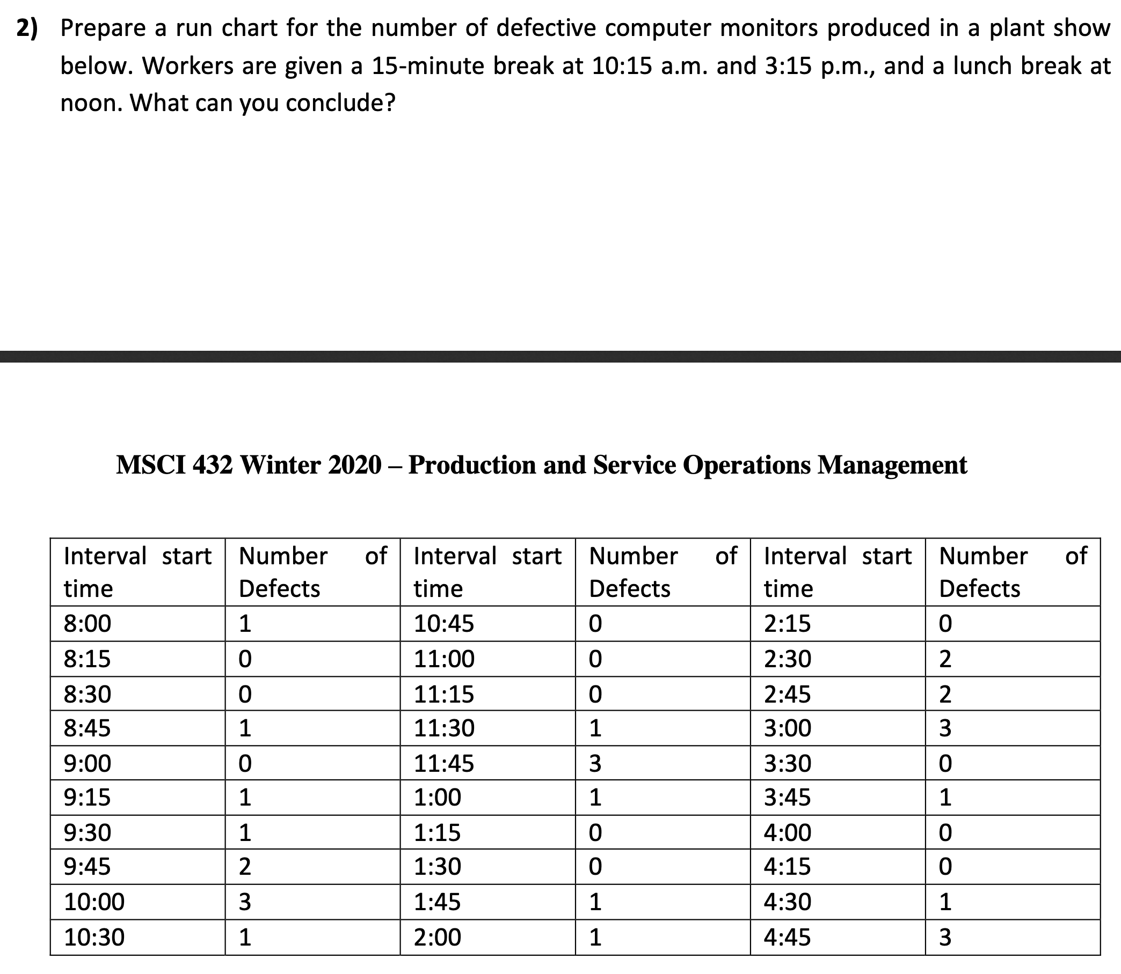

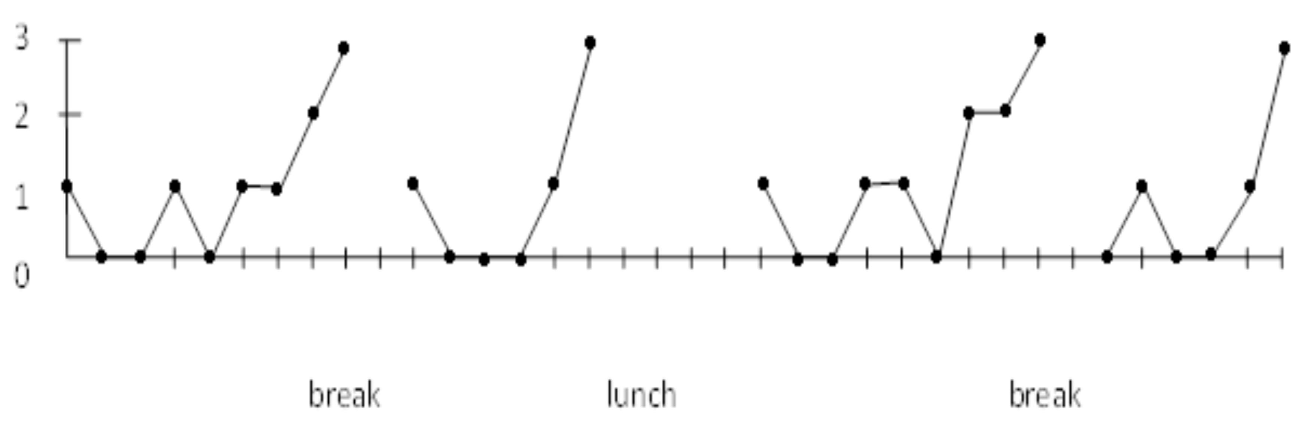

Increasing pattern of errors just before the break times, lunch, and the end of the shift.

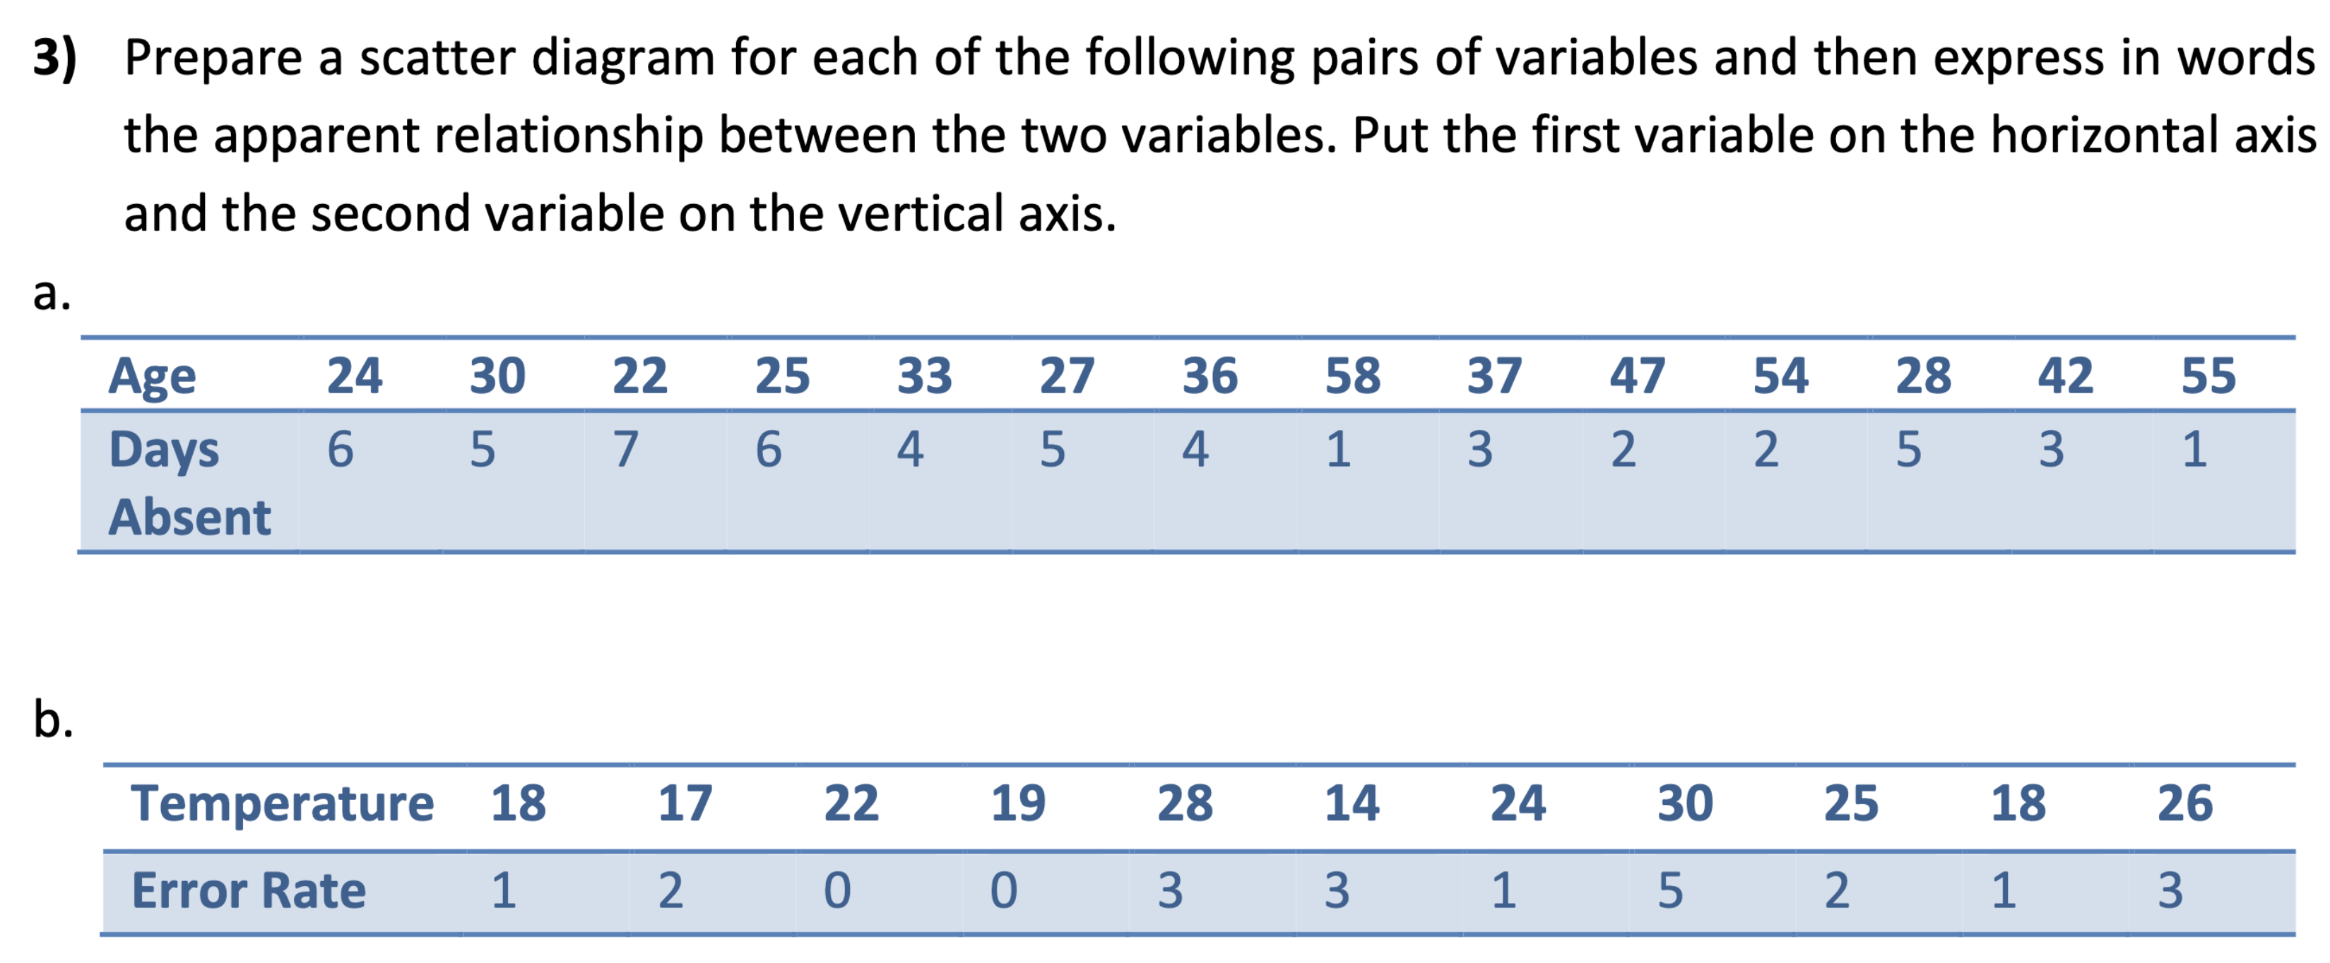

1. Scatter diagram for $a$:

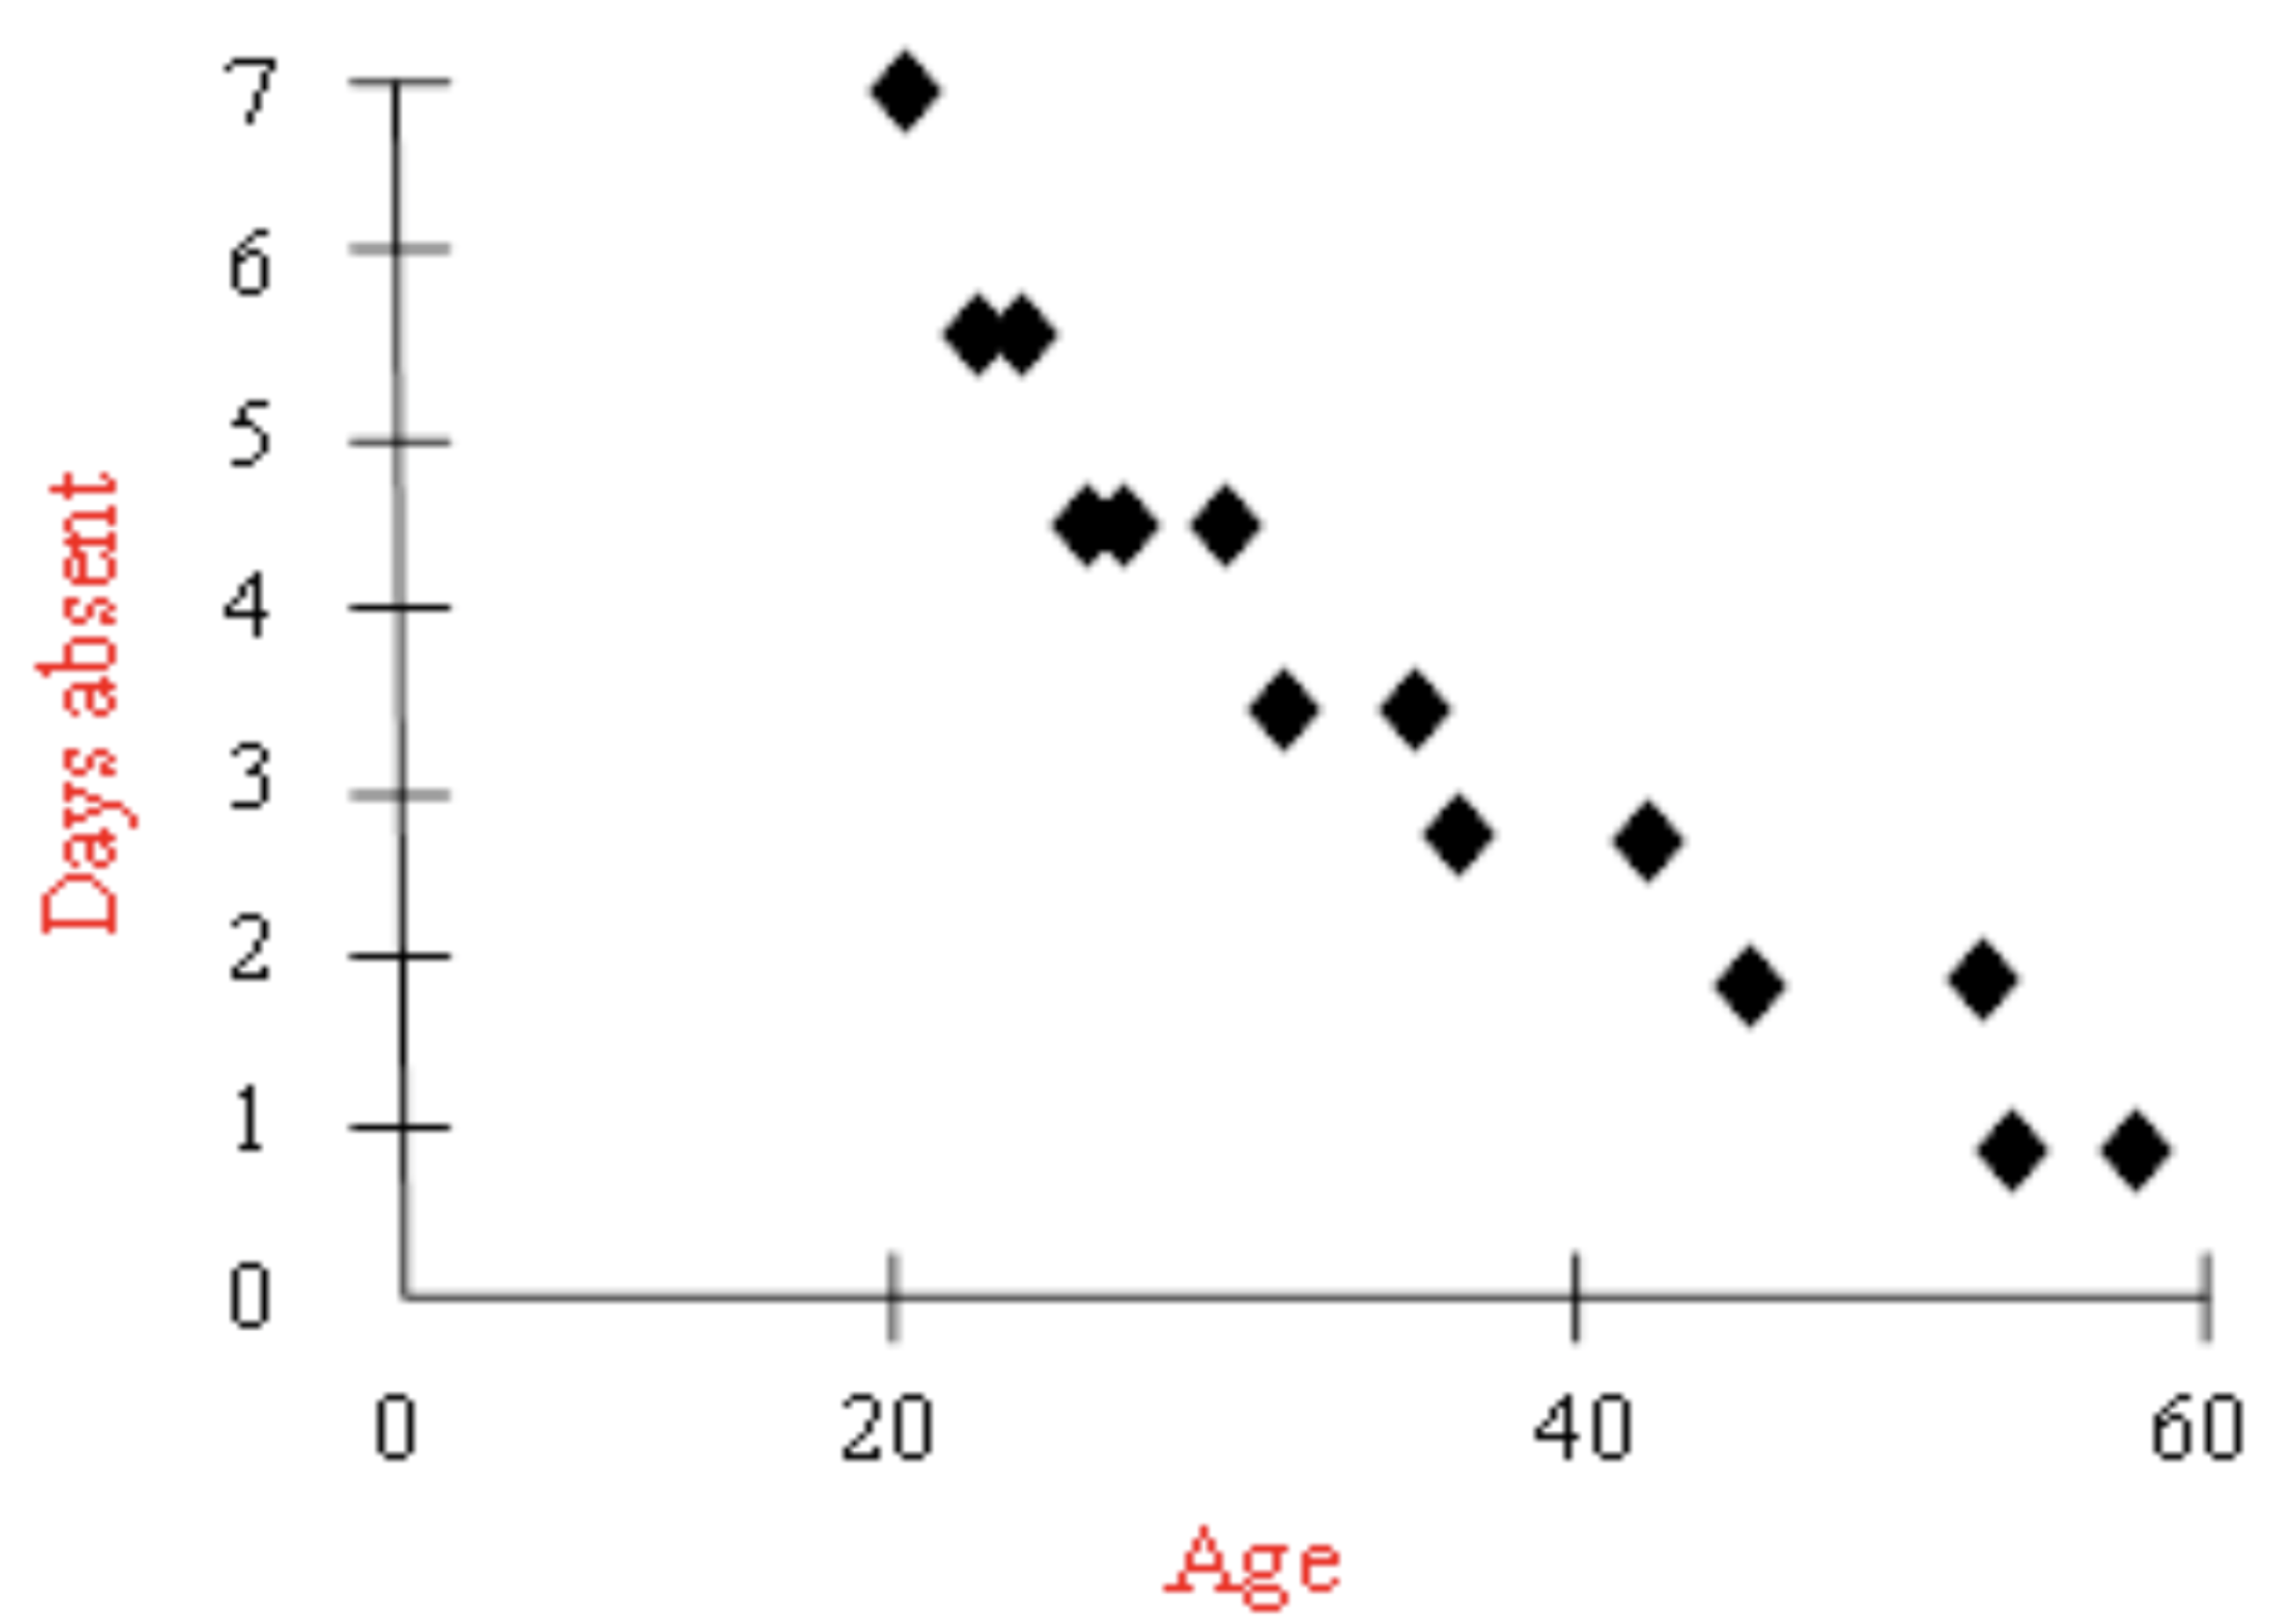

Age and days absent are inversely related. Older employees missed fewer days.

1. Scatter diagram for $b$:

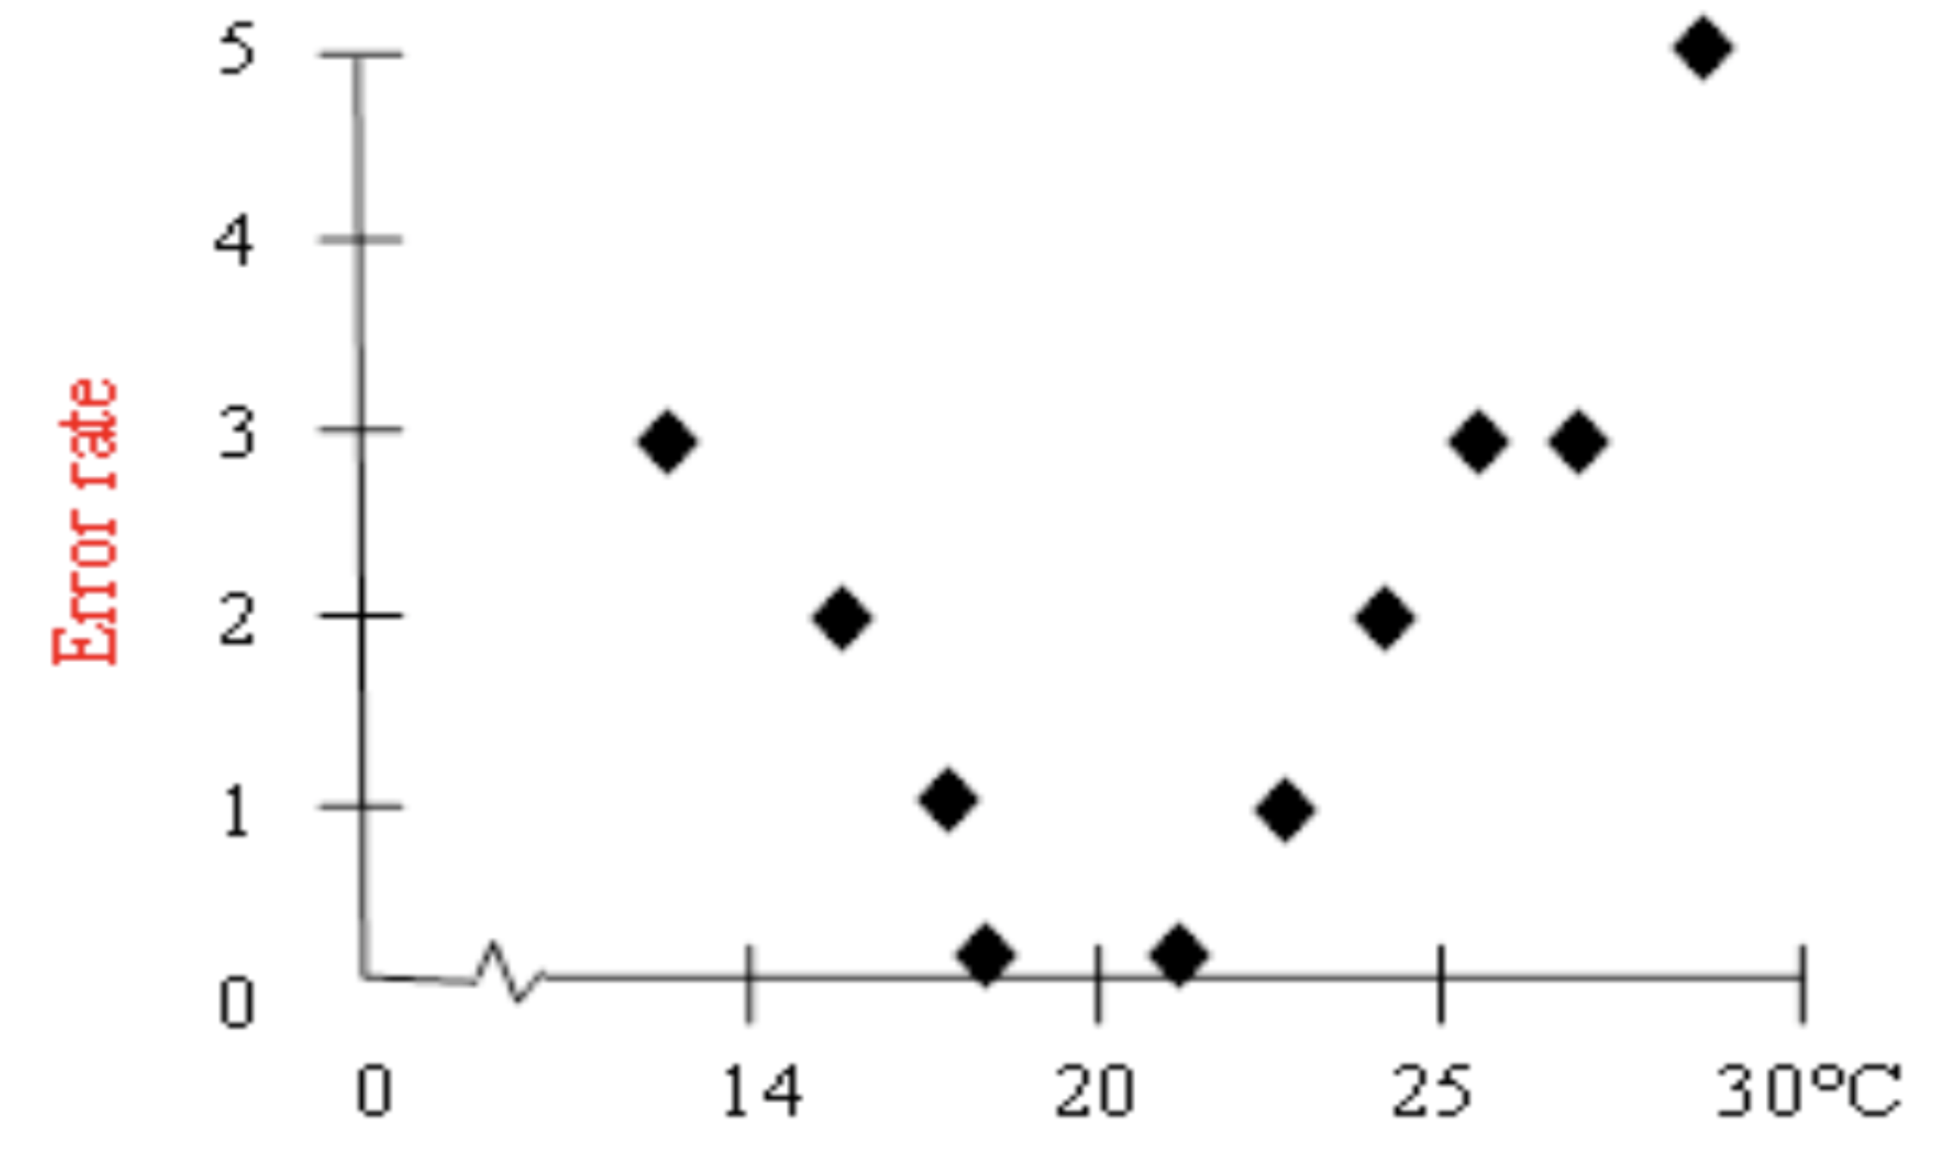

Error rate is non-linearly related to temperature. It increases in colder or hotter temperatures. The lowest error rate occurs around .



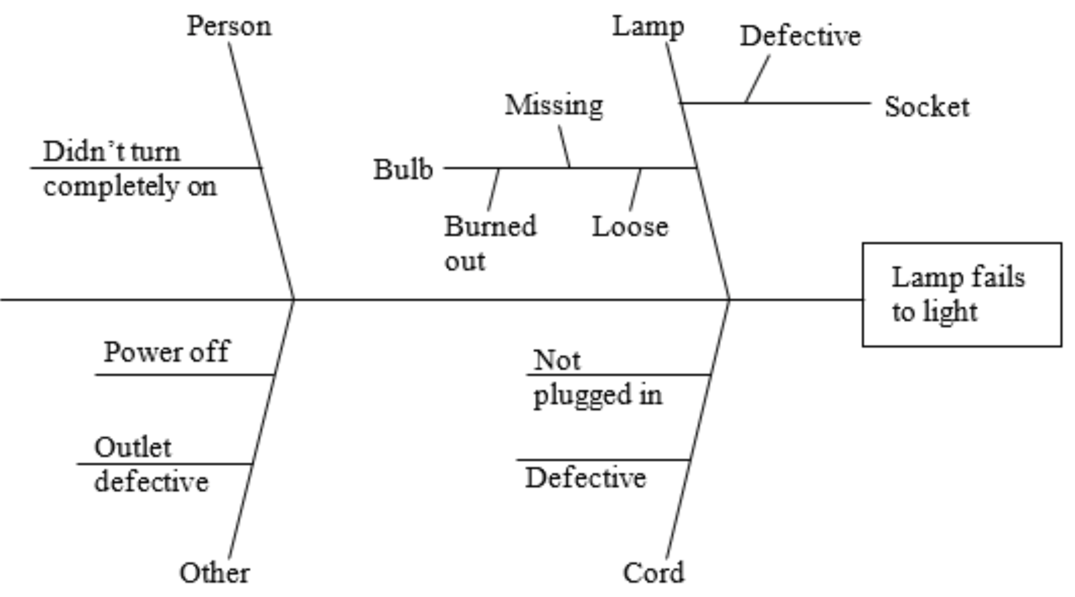

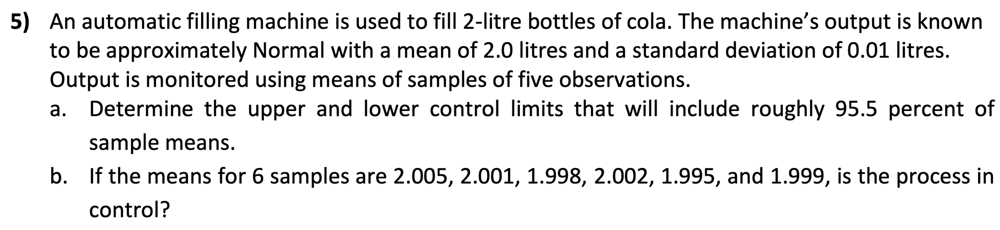

1. Control limits: $μ±z\frac{σ}{\sqrt{n}}$

$95.44\%→z=2$

$UCL=2.0+2\frac{0.01}{\sqrt{5}}=2.009 litres$

$LCL=2.0-2\frac{0.01}{\sqrt{5}}=1.991 litres$

1. Yes, because they all fall within the control limits and the pattern of data seems random.



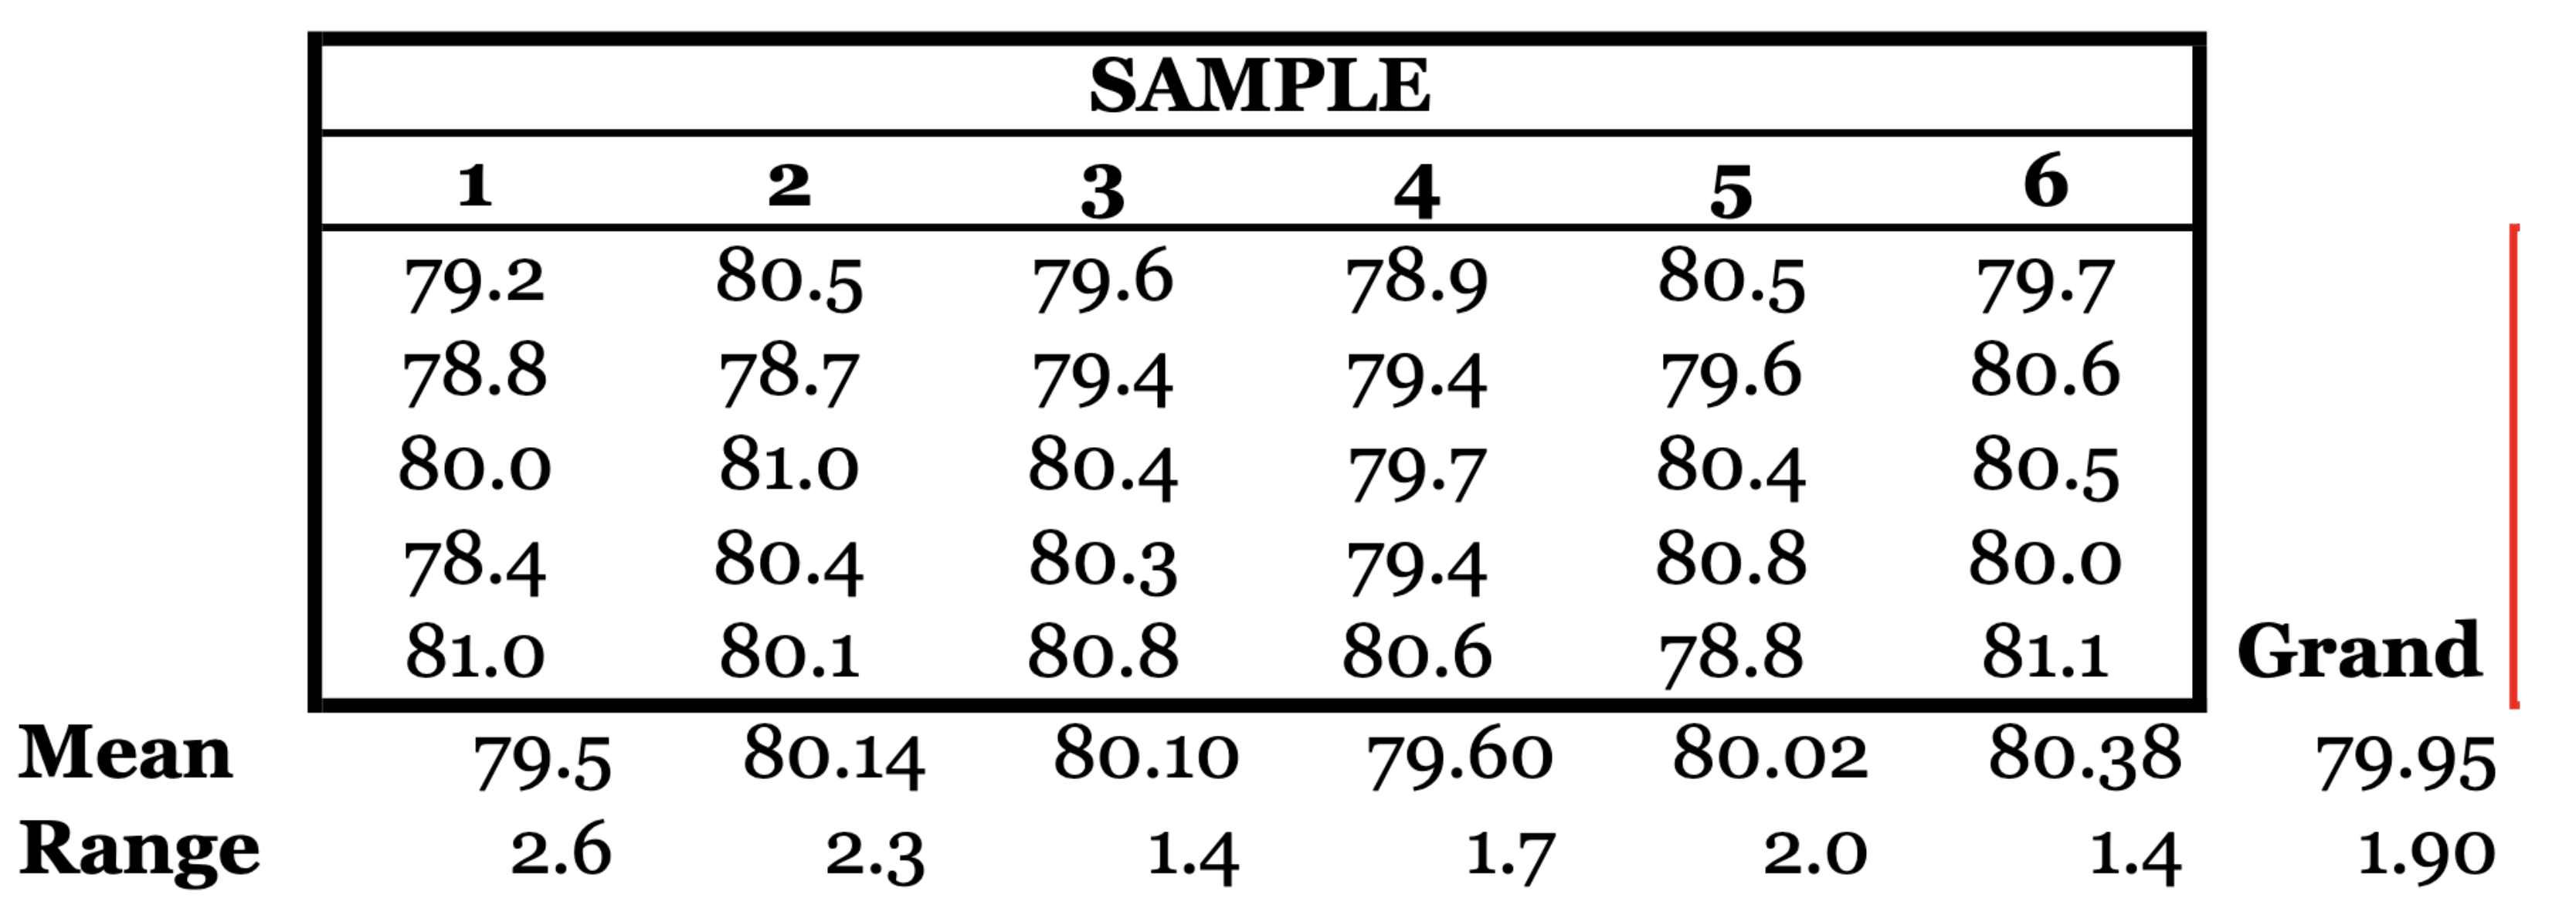

Mean control limits:

$$\overset{̿}{X}±A_{2}\overline{R}=79.95±0.58\left(1.90\right)=79.95±1.1$$

$$UCL=81.05, LCL=78.85$$

Range control limits:

$$UCL=D_{4}\overline{R}=2.11\left(1.90\right)=4.009$$

$$LCL=D_{3}\overline{R}=0\left(1.90\right)=0$$

Process is in control because all sample means and ranges fall within respective control limits.

7. Type I error concludes a process has changed when it actually has not, and Type II error concludes a process is in control when it is actually not.

# Tutorial 5: Supply Chain Management

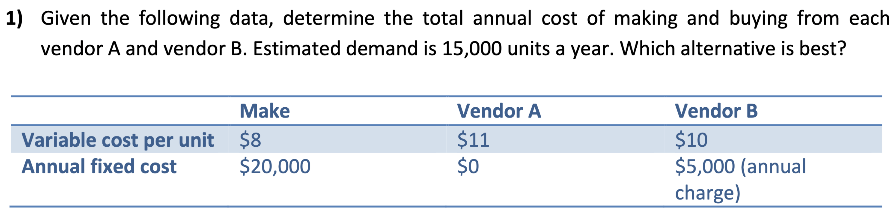

$$Total Annual Cost=Fixed Cost+Variable Cost Per Unit×Annual Quantity \\ Make: \$20,000+\$8×15,000=\$140,000 \\ Vendor A: \$0+\$11×15,000=\$165,000 \\ Vendor B:\$5,000+\$10×15,000=\$155,000$$

Thus, making the products yourself would be the best alternative.

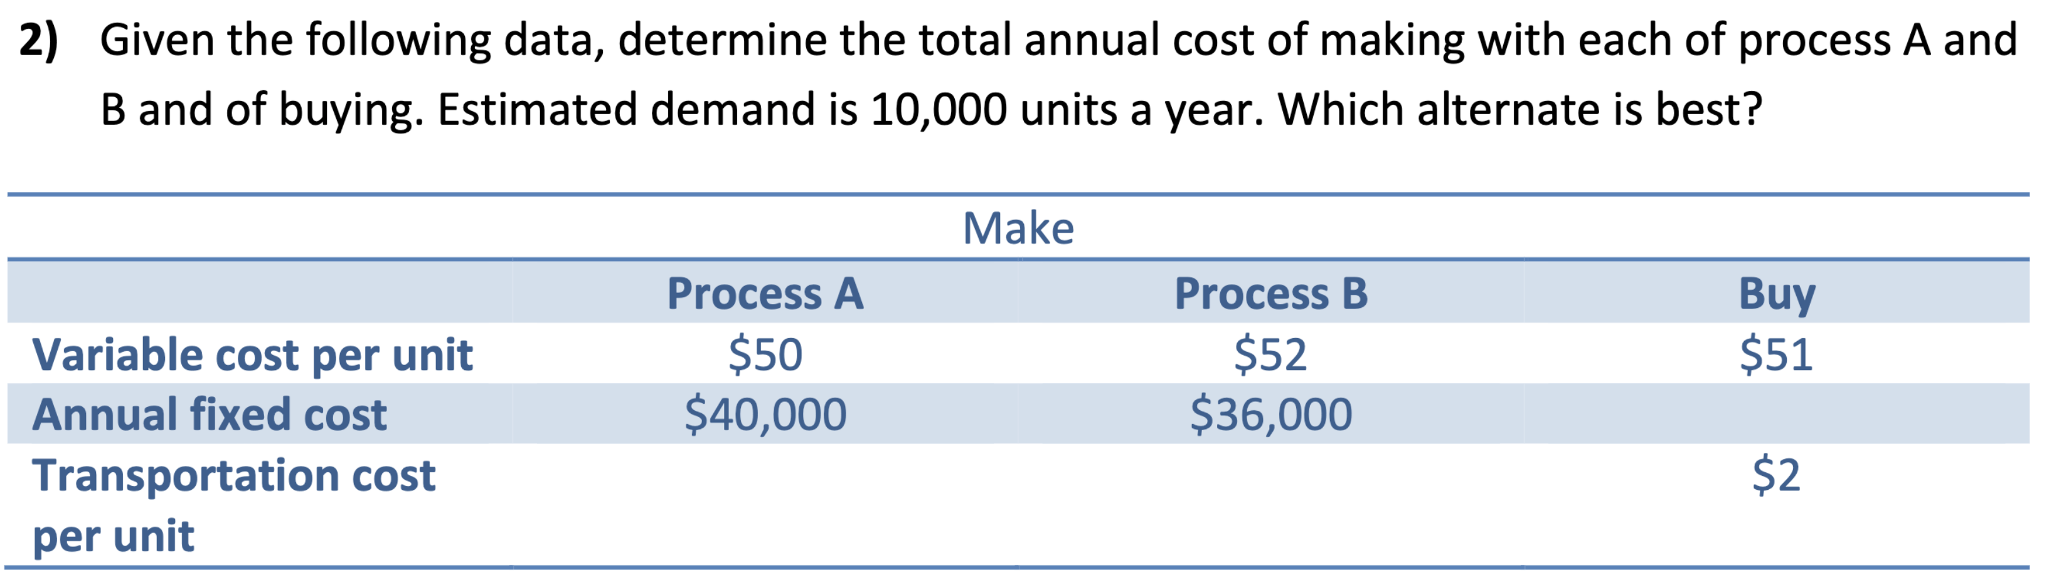

$$Process A: \$40,000+\$50×10,000=\$540,000 \\ Process B: \$36,000+\$52×10,000=\$556,000 \\ Buy: \$51×10,000+\$2×10,000=\$530,000$$

Thus, buying would have the lowest total annual cost.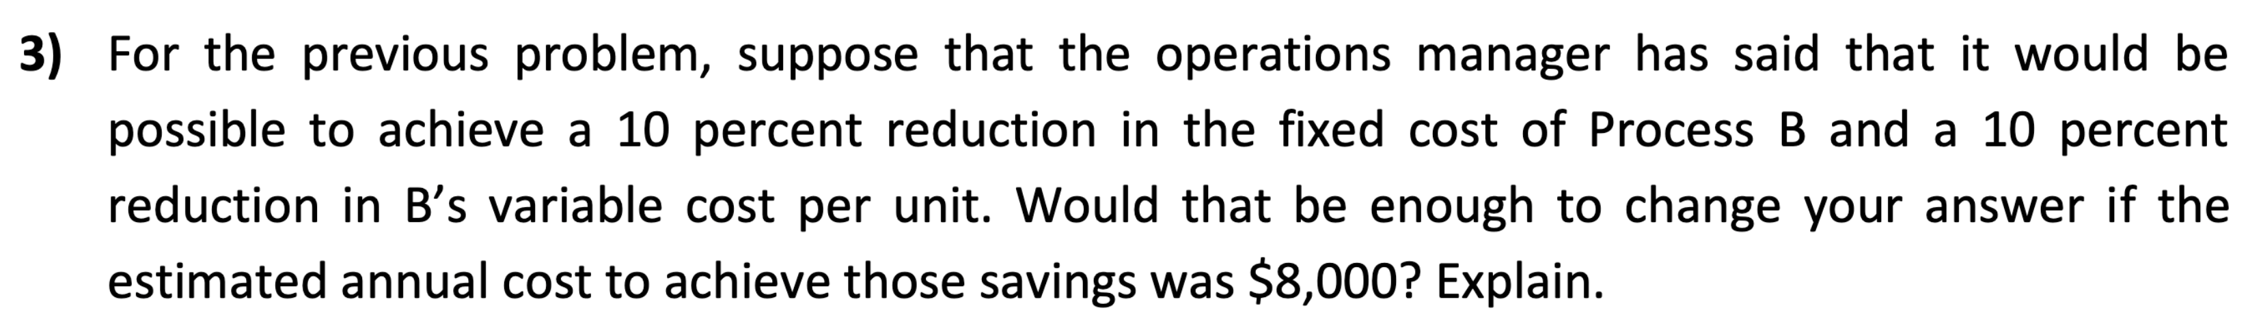

$$New Process B:\$36,000×0.9+\$8,000+\$52×0.9×10,000=\$508,400$$

Yes, the amount is less than buying, therefore make using Process B.

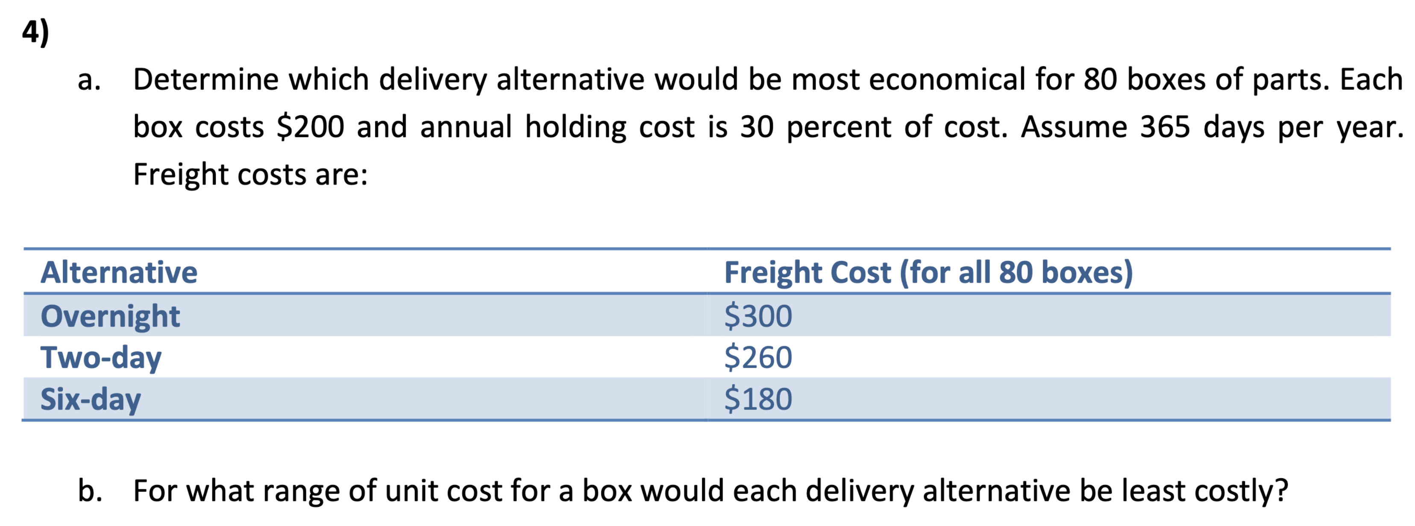



$$H=0.30×80 boxes×\$200=\$4,800$$

$Overnight: \$300+\$4800×\frac{1}{365}=\$313.15Two Day:\$260+\$4,800×\frac{2}{365}=\$286.30$ $Six Day: \$180+\$4,800×\frac{6}{365}=\$258.90$

Six-day alternative is cheapest.

1. $Let X=cost per box$. Then $H=24X$, and the total costs will be:

$$Overnight:\$300+\frac{24}{365}X$$

$$Two Day:\$260+\frac{48}{365}X$$

$$Six Day:\$180+\frac{144}{365}X$$

Overnight cheapest:

$$300+\frac{24}{365}X<260+\frac{48}{365}X⟹X>\$608.33 \\ 300+\frac{24}{365}X<180+\frac{144}{365}X⟹X>\$365.00$$

Two-day cheapest:

$$260+\frac{48}{365}X<300+\frac{24}{365}X⟹X<\$608.33$$

$$260+\frac{48}{365}X<180+\frac{144}{365}X⟹X>\$304.17$$

Six-day cheapest:

$$180+\frac{144}{365}X<300+\frac{24}{365}X⟹X<\$365.00$$

$$180+\frac{144}{365}X<260+\frac{48}{365}X⟹X<\$304.17$$

Overnight is cheapest if $unit cost>\$608.33$

Two-day cheapest if $\$304.17<unit cost<\$608.33$

Six-day cheapest if $unit cost<\$304.17$

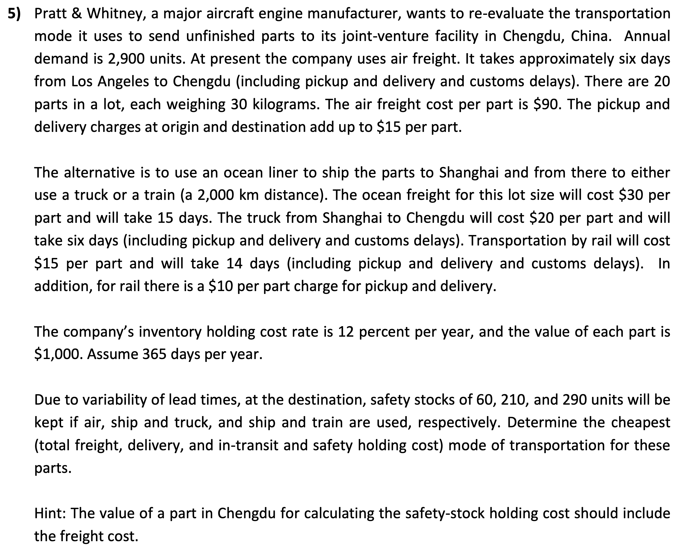

|  |  |  |
| --- | --- | --- |
| **Mode** | **Duration ($days$)** | **Cost ($\$$) Per Part** |
| Air | $$6$$ | $$90+15=105$$ |
| Ocean, Truck | $$15+6=21$$ | $$30+20=50$$ |
| Ocean, Train |  |  |

|  |  |
| --- | --- |
| **Mode** | **Annual Freight & Delivery Costs** |
| Air | $$\$105×2,900=\$304,500$$ |
| Ocean, Truck | $$\$50×2,900=\$145,000$$ |
| Ocean, Train | $$\$55×2,900=\$159,500$$ |
| **Mode** | **Annual In-Transit Holding Costs** |
| Air | $$\$1,000×0.12×\frac{6}{365}×2,900=\$5,720.55$$ |
| Ocean, Truck | $$\$1,000×0.12×\frac{21}{365}×2,900=\$20,021.92$$ |
| Ocean, Train |  |

|  |  |
| --- | --- |
| **Mode** | **Annual Safety Stock Holding Costs** |
| Air | $$60×\left(\$1,000+\$105\right)×0.12=\$7,956$$ |
| Ocean, Truck | $$210×\left(\$1,000+\$50\right)×0.12=\$26,460$$ |
| Ocean, Train |  |

|  |  |
| --- | --- |
| **Mode** | **Annual Total Cost** |
| Air | $$\$304,500+\$5,720.55+\$7,956=\$318,176.55$$ |
| Ocean, Truck | $$\$145,000+\$20,021.92+\$26,460=\$191,481.92$$ |
| Ocean, Train | $$\$159,500+\$27,649.32+\$36,714=\$223,863.32$$ |

The cheapest mode of transportation for these parts is by ocean and truck.

# Tutorial 6: Inventory Management I

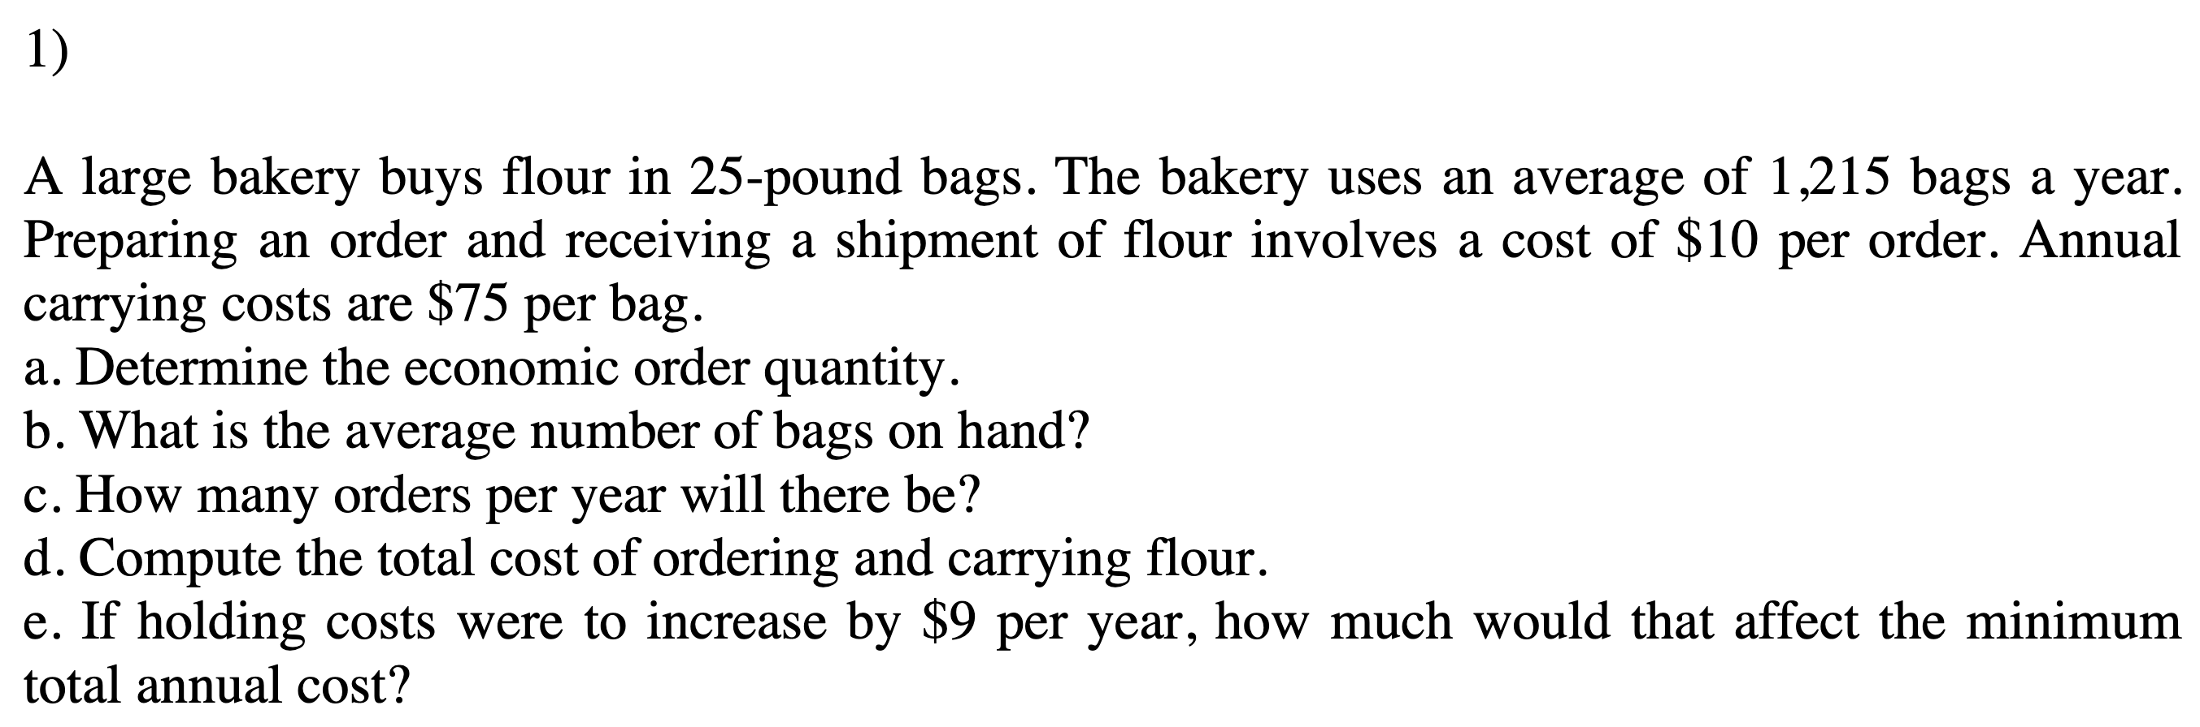

$$D=1,215 bags a year, S=\$10 per order, H=\$75 per bag$$

$Q_{0}=\sqrt{\frac{2DS}{H}}=\sqrt{\frac{2\left(1,215\right)\left(10\right)}{75}}=\sqrt{324}=18 bags$

The EOQ of the bakery is $18$ bags.

$Average inventory level=\frac{Q_{0}}{2}=\frac{18}{2}=9 bags$

The average number of bags on hand is $9$.

$Orders per year=\frac{Annual demand}{Economic order quantity}=\frac{1,215}{18}=67.5 bags$

The number of orders per year is $67.5$ bags.

$Total cost=Carrying cost+Ordering cost$

$Total cost=\frac{Q_{0}}{2}H+\frac{D}{Q_{0}}S=\frac{18}{2}×75+\frac{1,215}{18}×10=\$1,350$

Total cost of ordering and holding flour is $\$1,350$.

$New carrying cost=\$75+\$9=\$84$

$Q_{0}=\sqrt{\frac{2\left(1,215\right)\left(10\right)}{84}}=\sqrt{289.28}=17.27 bags$ (round to $17$ bags)

$New total cost=\frac{17}{2}×84+\frac{1,215}{17}×10=\$1,428.70$

$Affect in total cost=New total cost-Old total cost$

$Affect in total cost=\$1,428.70-\$1,350=\$78.70$

The affect in total cost is $\$78.70$.

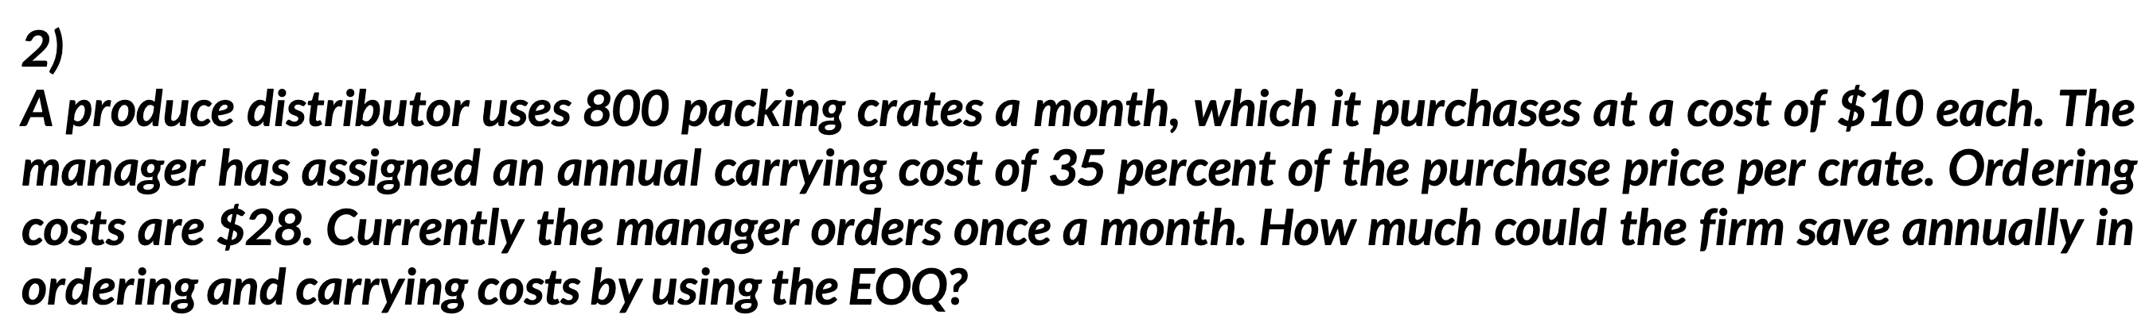

$$Crates/month=800, Purchase cost/crate=\$10, H=35\% of purchase cost, S=\$28$$

Step 1: Calculate the annual demand:

$$D=Monthly demand×12=800×12=9,600 crates$$

Step 2: Calculate carrying cost:

$$H=0.35×\$10=\$3.5$$

Step 3: Calculate the EOQ:

$$Q_{0}=\sqrt{\frac{2DS}{H}}=\sqrt{\frac{2\left(9,600\right)\left(28\right)}{3.5}}=\sqrt{153,600}=391.92≈392 crates$$

Step 4: Calculate the total cost when EOQ is ordered:

$$Total cost=Carrying cost+Order cost=\frac{Q}{2}H+\frac{D}{Q}S \\ Total cost_{EOQ}=\frac{392}{2}×3.5+\frac{9,600}{392}×28=686+685.7=\$1,372$$

Step 5: Calculate the total cost when $800$ units are ordered per month:

$$Total cost_{800}=\frac{800}{2}×3.5+\frac{9,600}{800}×28=1,400+336=\$1,736$$

Step 6: Calculate the savings when EOQ is used:

$$Amount saved=Total cost_{800}-Total cost_{EOQ}=\$1,736-\$1,372=\$364$$

The amount that will be saved using EOQ is $\$364$.

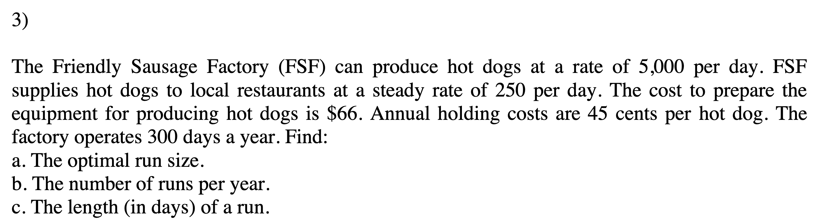

$$p=5,000/day, d=250/day, S=\$66, H=\$0.45/hot dog, days/year=300$$

$D=usage rate×\# of working days=250×300=75,000 hot dogs/year$

$Q_{p}=\sqrt{\frac{2DS}{H}}\sqrt{\frac{p}{p-d}}=\sqrt{\frac{2\left(75,000\right)\left(66\right)}{0.45}}\sqrt{\frac{5,000}{5,000-250}}=4812.37≈4,812$

The optimal run size is $4,812$.

$Number of runs per year=\frac{D}{Q_{p}}=\frac{75,000}{4,812}=15.59 runs per year$

The number of runs per year is $15.59$.

$Number of days of a run=\frac{Q_{p}}{p}=\frac{4,812}{5,000}=0.96 days$

The number of days to produce optimal run capacity is $0.96$ days.

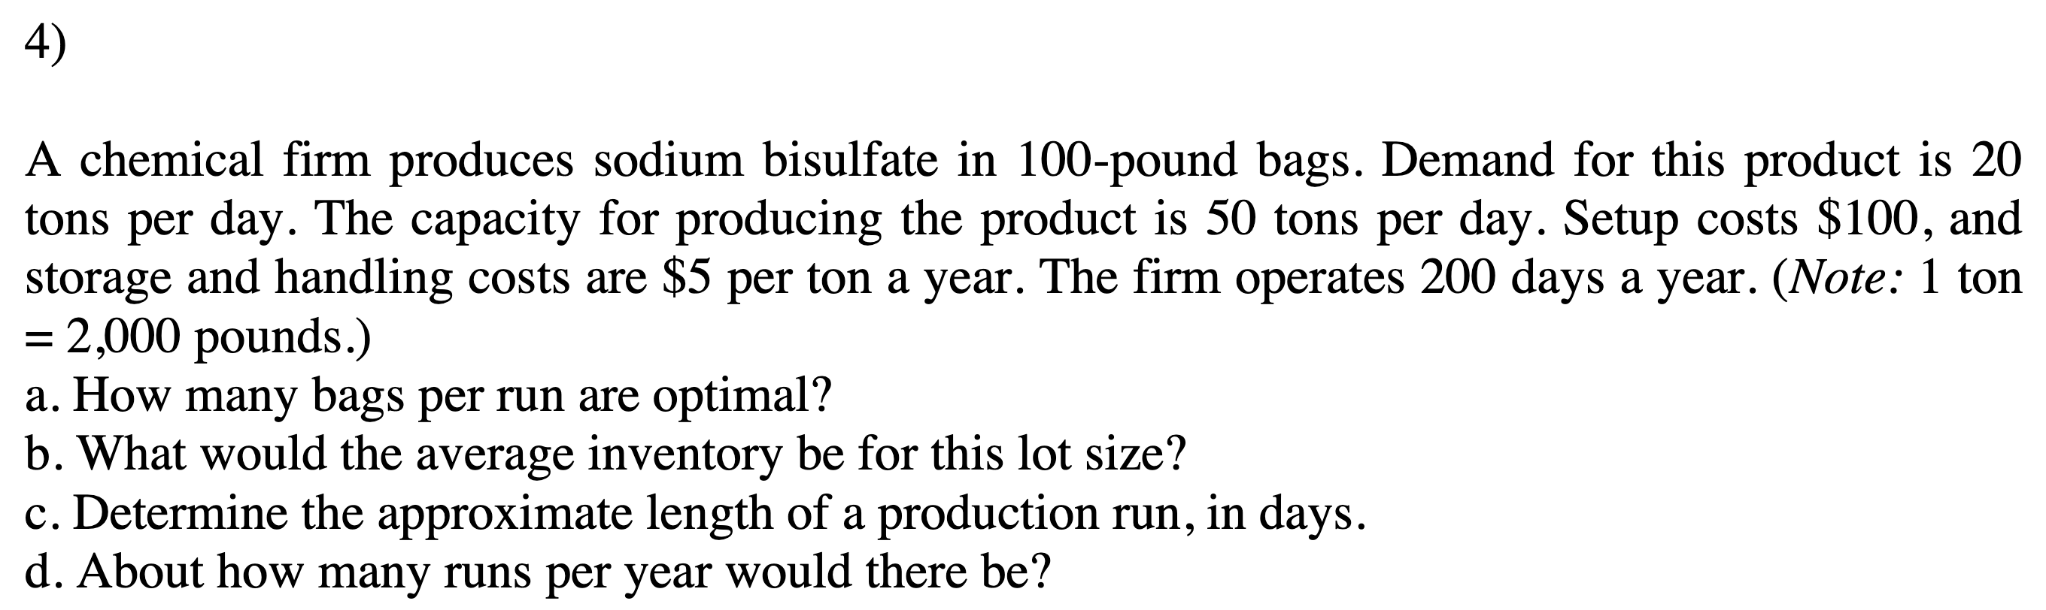



Hence, $D=4,000$ tons.

1. Step 1: Calculate the optimum quantity using the EPQ formula:

$Q=\sqrt{\frac{2DS}{H}}\sqrt{\frac{p}{p-d}}=\sqrt{\frac{2\left(4,000\right)\left(100\right)}{5}}\sqrt{\frac{50}{50-20}}=516.4 tons$

Step 2: Calculate the maximum inventory:

$I_{MAX}=\frac{Q}{p}\left(p-d\right)=\frac{516.4}{50}\left(50-20\right)=309.84 tons$

Step 3: Calculate the average inventory:

$Average inventory=\frac{I_{MAX}}{2}=\frac{309.84}{2}=154.92$

The average inventory for this lot size is $154.92$.

$Length of production time=\frac{Q}{p}=\frac{516.4}{50}=10.33 days$

The approximate length of a production run is $10.33$ days.

$Production runs per year=\frac{D}{Q}=\frac{4,000}{516.4}=7.75 runs≈8 runs$

The number of runs per year are about $8$ runs.

1. Step 1: Calculate the total cost of production at the current setup cost:

$Total cost=\frac{I_{MAX}}{2}×H+\frac{D}{Q}×S=\frac{309.84}{2}×\$5+\frac{4,000}{516.4}×\$100=\$1,549$

Step 2: Now, at the new setup cost, calculate the new optimal production quantity:

$Q=\sqrt{\frac{2DS}{H}}\sqrt{\frac{p}{p-d}}=\sqrt{\frac{2\left(4,000\right)\left(25\right)}{5}}\sqrt{\frac{50}{50-20}}=258.2 tons$

Step 3: Calculate the new maximum inventory:

$I_{MAX}=\frac{Q}{p}\left(p-d\right)=\frac{258.2}{50}\left(50-20\right)=154.92 tons$

Step 4: Calculate the new total cost:

$Total cost=\frac{I_{MAX}}{2}×H+\frac{D}{Q}×S=\frac{154.92}{2}×\$5+\frac{4,000}{258.2}×\$25=\$774.5$

Step 5: Calculate the different between the total costs:

$Difference=\$1,549-\$774.5=\$774.5$

The company can save $\$774.5$ by reducing the setup cost to .

5) Explain briefly how a higher carrying cost can result in a decrease in inventory.

As holding inventory becomes more expensive, the company will order in smaller quantities (note $H$ in the formula for EOQ). This will result in more frequent orders.

6) Explain how a decrease in setup time can lead to a decrease in the average amount of inventory a firm holds, and why that would be beneficial.

As machine setup time decreases, setup cost decreases, resulting in lower run size (note $S$ in the EPQ), which results in lower average amount of WIP inventory. Overall inventory costs would decrease. Also, lower WIP results in less confusion and better quality.

7. When does the total cost curve reach its minimum value?

When $Ordering costs=Carrying costs$.

# Tutorial 7: Inventory Management II

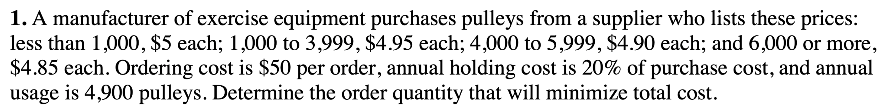

$D=4,900 pulleys/year$, $H=0.20R$, $S=\$50$

|  |  |
| --- | --- |
| **Range** | **R** |
| $$0-999$$ | $$\$5.00$$ |
| $$1,000-3,999$$ | $$\$4.95$$ |
| $$4,000-5,999$$ | $$\$4.90$$ |
| $$6,000+$$ | $$\$4.85$$ |

$EOQ_{R=\$4.85}=\sqrt{\frac{2DS}{iR}}=\sqrt{\frac{2\left(4,900\right)\left(50\right)}{0.20\left(4.85\right)}}=710.7$ or $711$ pulleys. $711<6,000$, EOQ is not feasible.

$EOQ_{R=\$4.90}=\sqrt{\frac{2\left(4,900\right)\left(50\right)}{0.20\left(4.90\right)}}=707.1$ or $707$ pulleys. $707<4,000$, EOQ is not feasible.

$EOQ_{R=\$4.95}=\sqrt{\frac{2\left(4,900\right)\left(50\right)}{0.20\left(4.95\right)}}=703.53$ or $704$ pulleys. $704<1,000$, EOQ is not feasible.

$EOQ_{R=\$5.00}=\sqrt{\frac{2\left(4,900\right)\left(50\right)}{0.20\left(5.00\right)}}=700$ pulleys. $0≤700<999$, EOQ is feasible. Next, need to compare total cost of $Q=700$ units with those of $Q=1,000$, $Q=4,000$, $Q=6,000$.

$$TC_{700}=\frac{Q}{2}H+\frac{D}{Q}S+RD=\frac{700}{2}\left(0.20\right)\left(5.00\right)+\frac{4,900}{700}\left(50\right)+5.00\left(4,900\right)=\$25,200$$

$$TC_{1,000}=\frac{1,000}{2}\left(0.20\right)\left(4.95\right)+\frac{4,900}{1,000}\left(50\right)+4.95\left(4,900\right)=\$24,995$$

$$TC_{4,000}=\frac{4,000}{2}\left(0.20\right)\left(4.90\right)+\frac{4,900}{4,000}\left(50\right)+4.90\left(4,900\right)=\$26,031.25$$

$$TC_{6,000}=\frac{6,000}{2}\left(0.20\right)\left(4.85\right)+\frac{4,900}{6,000}\left(50\right)+4.85\left(4,900\right)=\$26,715.83$$

Therefore, the order quantity that will minimize total cost is $1,000$.

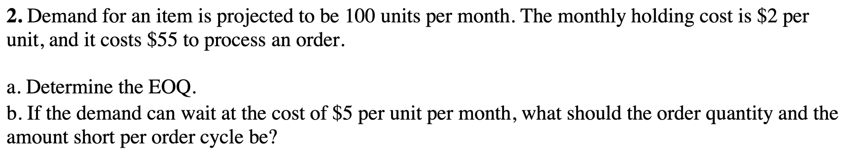

$D=100 units/month$, $H=\$2/unit/month$, $S=\$55$

1. $EOQ=\sqrt{\frac{2DS}{H}}=\sqrt{\frac{2\left(100\right)\left(55\right)}{2}}=74.16$ round to $74$ units

$B=\$5/unit/month$

$Q=\sqrt{\frac{2DS}{H}×\frac{H+B}{B}}=\sqrt{\frac{2\left(100\right)\left(55\right)}{2}×\frac{2+5}{5}}=87.75$ round to $88$ units

$Q_{b}=Q×\frac{H}{H+B}=88×\frac{2}{2+5}=25.1$ round to 25

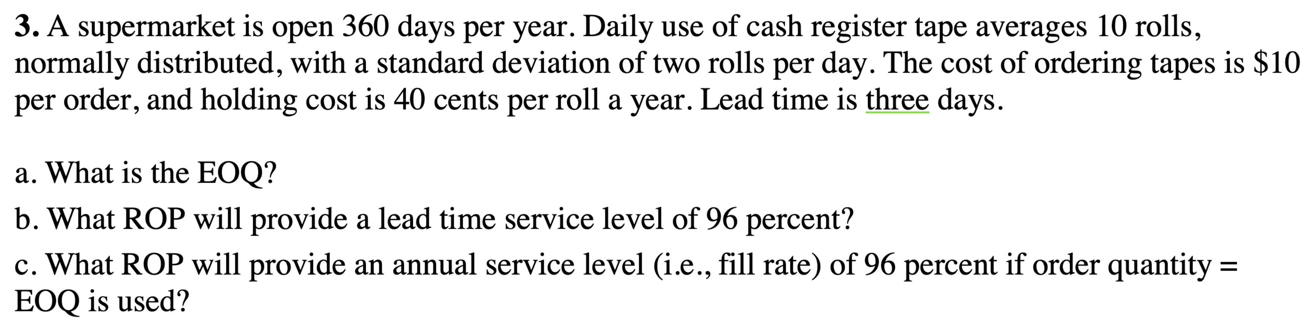

$360 days$, $\overline{d}=10 rolls/day$, $σ_{d}=2 rolls/day$, $S=\$10$, $H=\$0.40/roll/year$, $LT=3$

$D=\overline{d}×number of days=10 rolls/day×360 days/year=3,600 rolls/year$

$EOQ=\sqrt{\frac{2DS}{H}}=\sqrt{\frac{2\left(3,600\right)\left(10\right)}{0.40}}=424.3$ round to $424$ rolls

1. Lead time $SL$ of $96\%→z=1.75$ from Table 12-3

$ROP=\overline{d}⋅LT+z\sqrt{LT}⋅σ_{d}=10\left(3\right)+1.75\sqrt{3}\left(2\right)=36.06$ round to $36$

$SL_{annual}=96\%=0.96$

$σ_{dLT}=σ_{d}\sqrt{LT}=2\sqrt{3}=3.46$

$E\left(z\right)=\frac{Q\left(1-SL_{annual}\right)}{σ_{dLT}}=\frac{424\left(1-0.96\right)}{3.46}=4.90$

$⟹$ Table 12-3 to get $z$, but $E\left(z\right)=4.90$ is not in the table.

However, note that for values of $E\left(z\right)>2.4$, $z=-E\left(z\right)$.

Therefore, for $E\left(z\right)=4.90$, $z=-4.90$.

$ROP=\overline{d}⋅LT+zσ_{dLT}=10\left(3\right)-4.90\left(3.46\right)=13.05$ round to 13

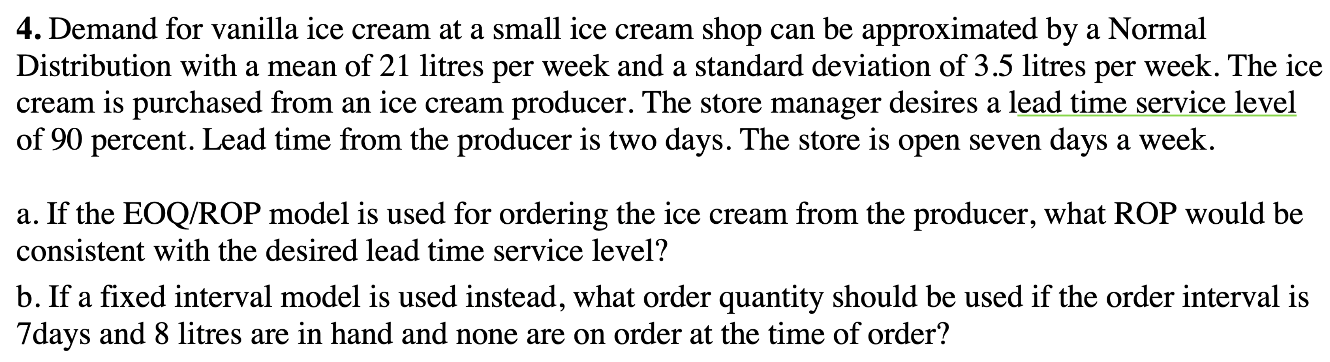

$\overline{d}=21 litres/wk$, $σ_{d}=3.5 litres/wk$, $SL=90\%$, $LT_{days}=2 days$, $open 7 days/wk$

1. $SL=0.9→z=1.28$ from Table 12-3

$LT_{weeks}=\frac{LT_{days}}{number of days/week}=\frac{2 days}{7 days/week}=\frac{2}{7} weeks$

$ROP=\overline{d}⋅LT+z\sqrt{LT}⋅σ_{d}=21\left(\frac{2}{7}\right)+1.28\sqrt{\frac{2}{7}}\left(3.5\right)=8.39 litres$

1. $OI_{days}=7 days$, $on hand \left(inventory position\right)=8 litres$, $I_{max}:order up to level$

$OI_{weeks}=\frac{OI_{days}}{number of days}=\frac{7 days}{7 days/week}=\frac{7}{7} weeks$

$I_{max}=\overline{d}\left(OI+LT\right)+z⋅σ_{d}\sqrt{OI+LT}=21\left(\frac{7}{7}+\frac{2}{7}\right)+1.28\left(3.5\right)\sqrt{\frac{7}{7}+\frac{2}{7}}=32.08$ round to 32 litres

$Q\left(order quantity\right)=I_{max}-on hand=32-8=24 litres$

# Tutorial 8: Aggregate Operations Planning

**Procedure for Trial-and-Error worksheet approach in aggregate planning:**

* Determine production output by permanent workers (during regular time) for each period.
* Determine total units short and periods short.
* Determine the cheapest way (using trade-off analysis) to meet the units short, e.g.,
  + Hire temporary and/or part-time workers.
  + Use permanent workers during overtime.
  + Carry inventory from previous periods.
  + Meet demand from following periods (backorder).

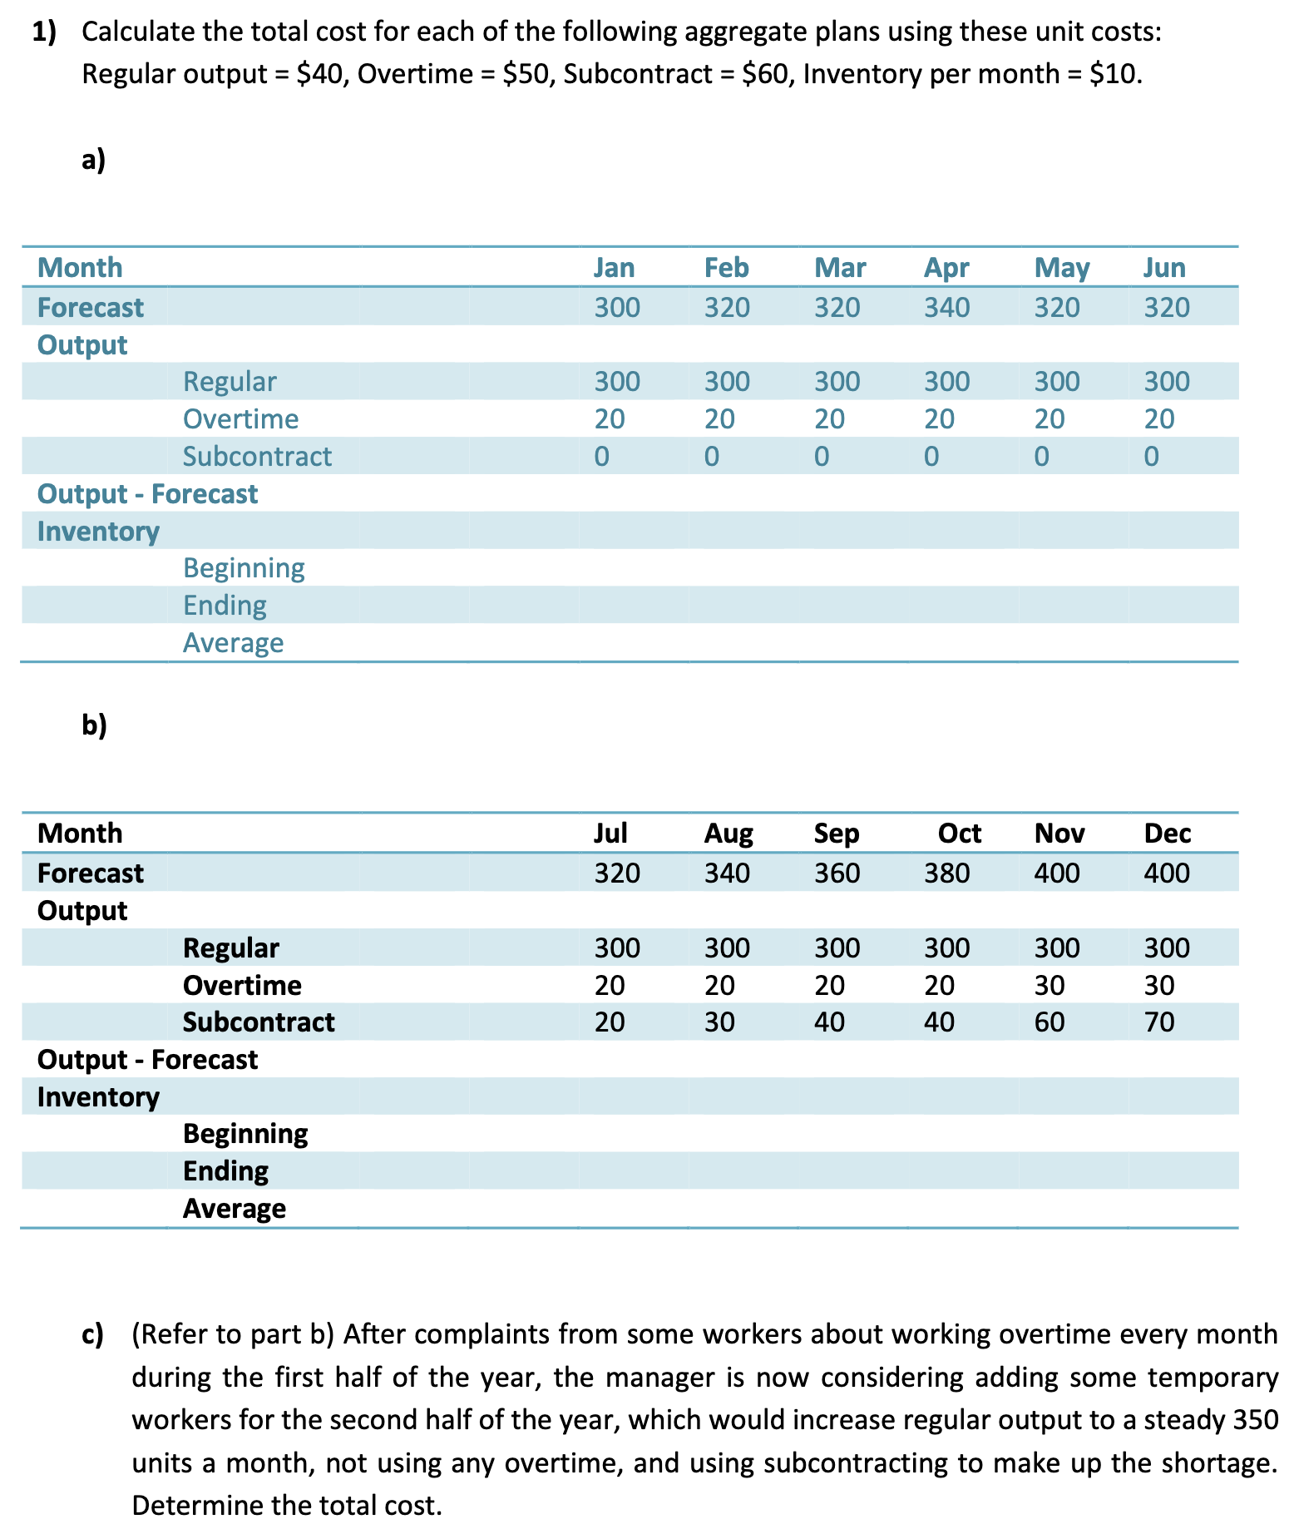

1. Total cost from January to June:

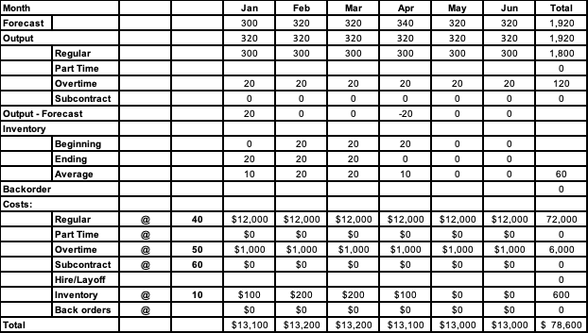

1. Total cost from July to December:

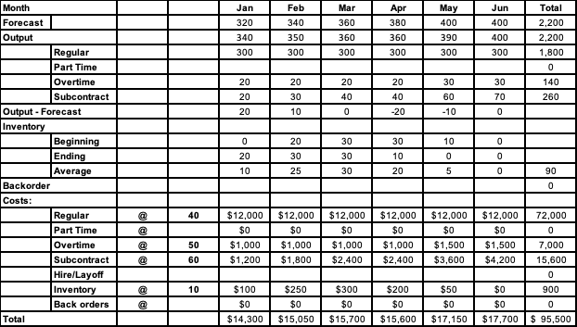

1. Increase regular output for overtime and subcontract:

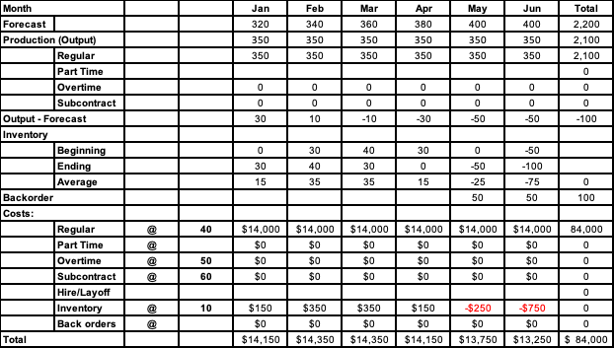

Add subcontract to eliminate backorder:

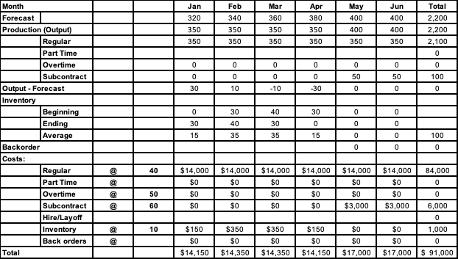

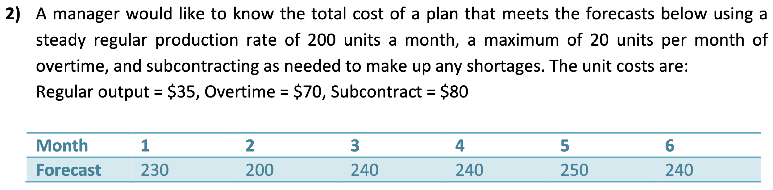

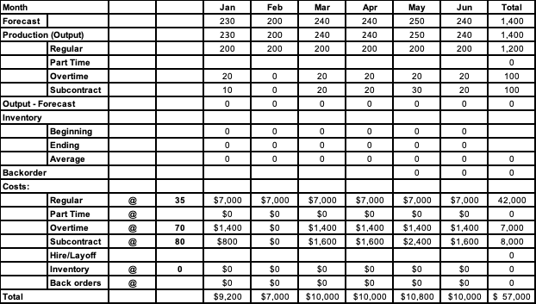

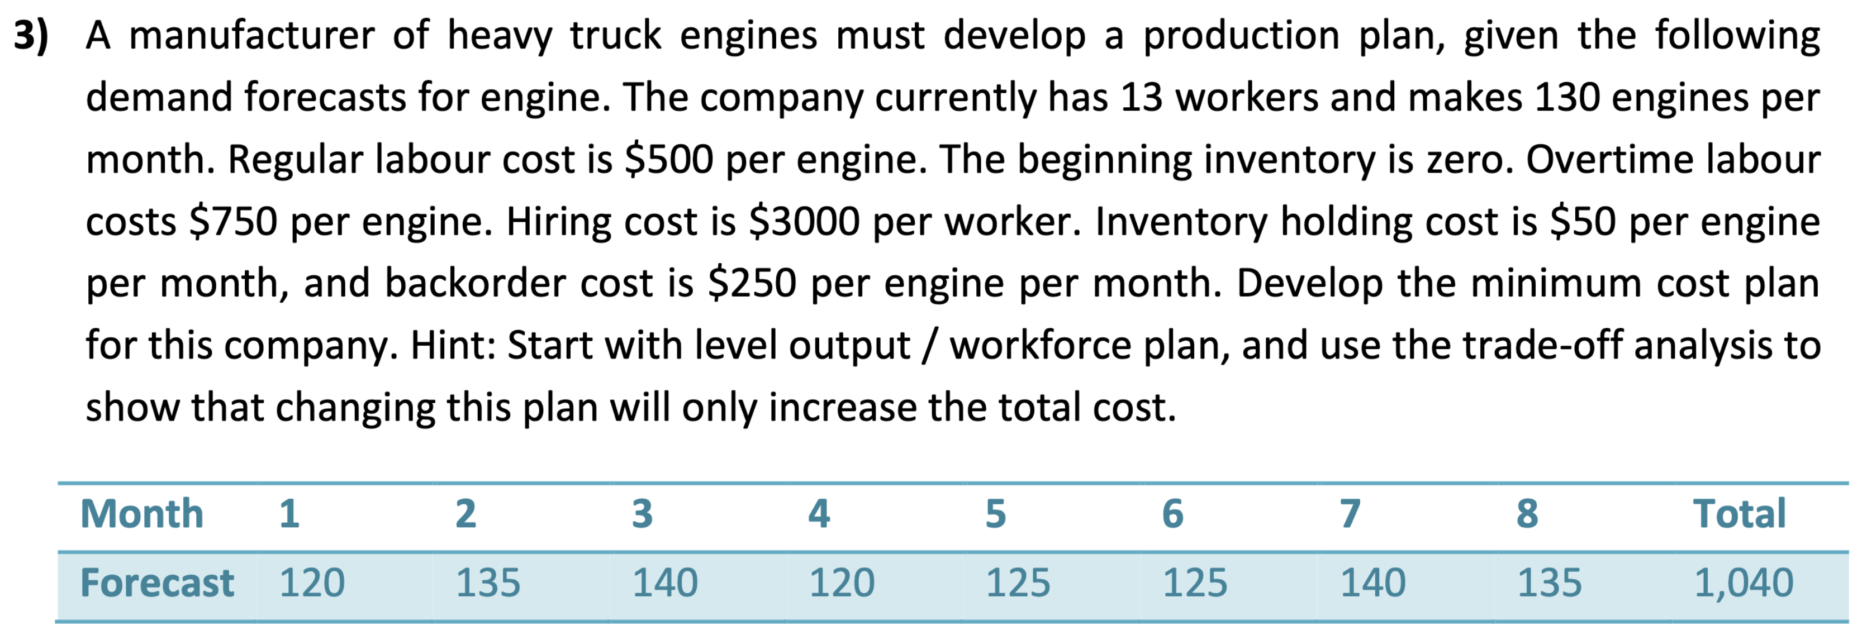

Meeting demand not using the backorder:

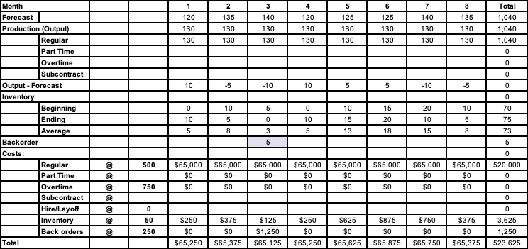

Meeting demand using the backorder:

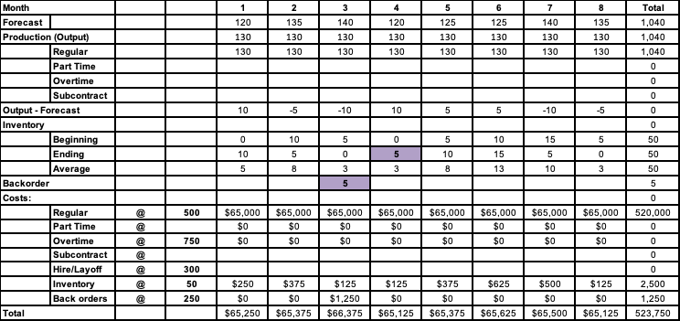

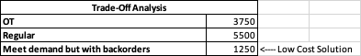

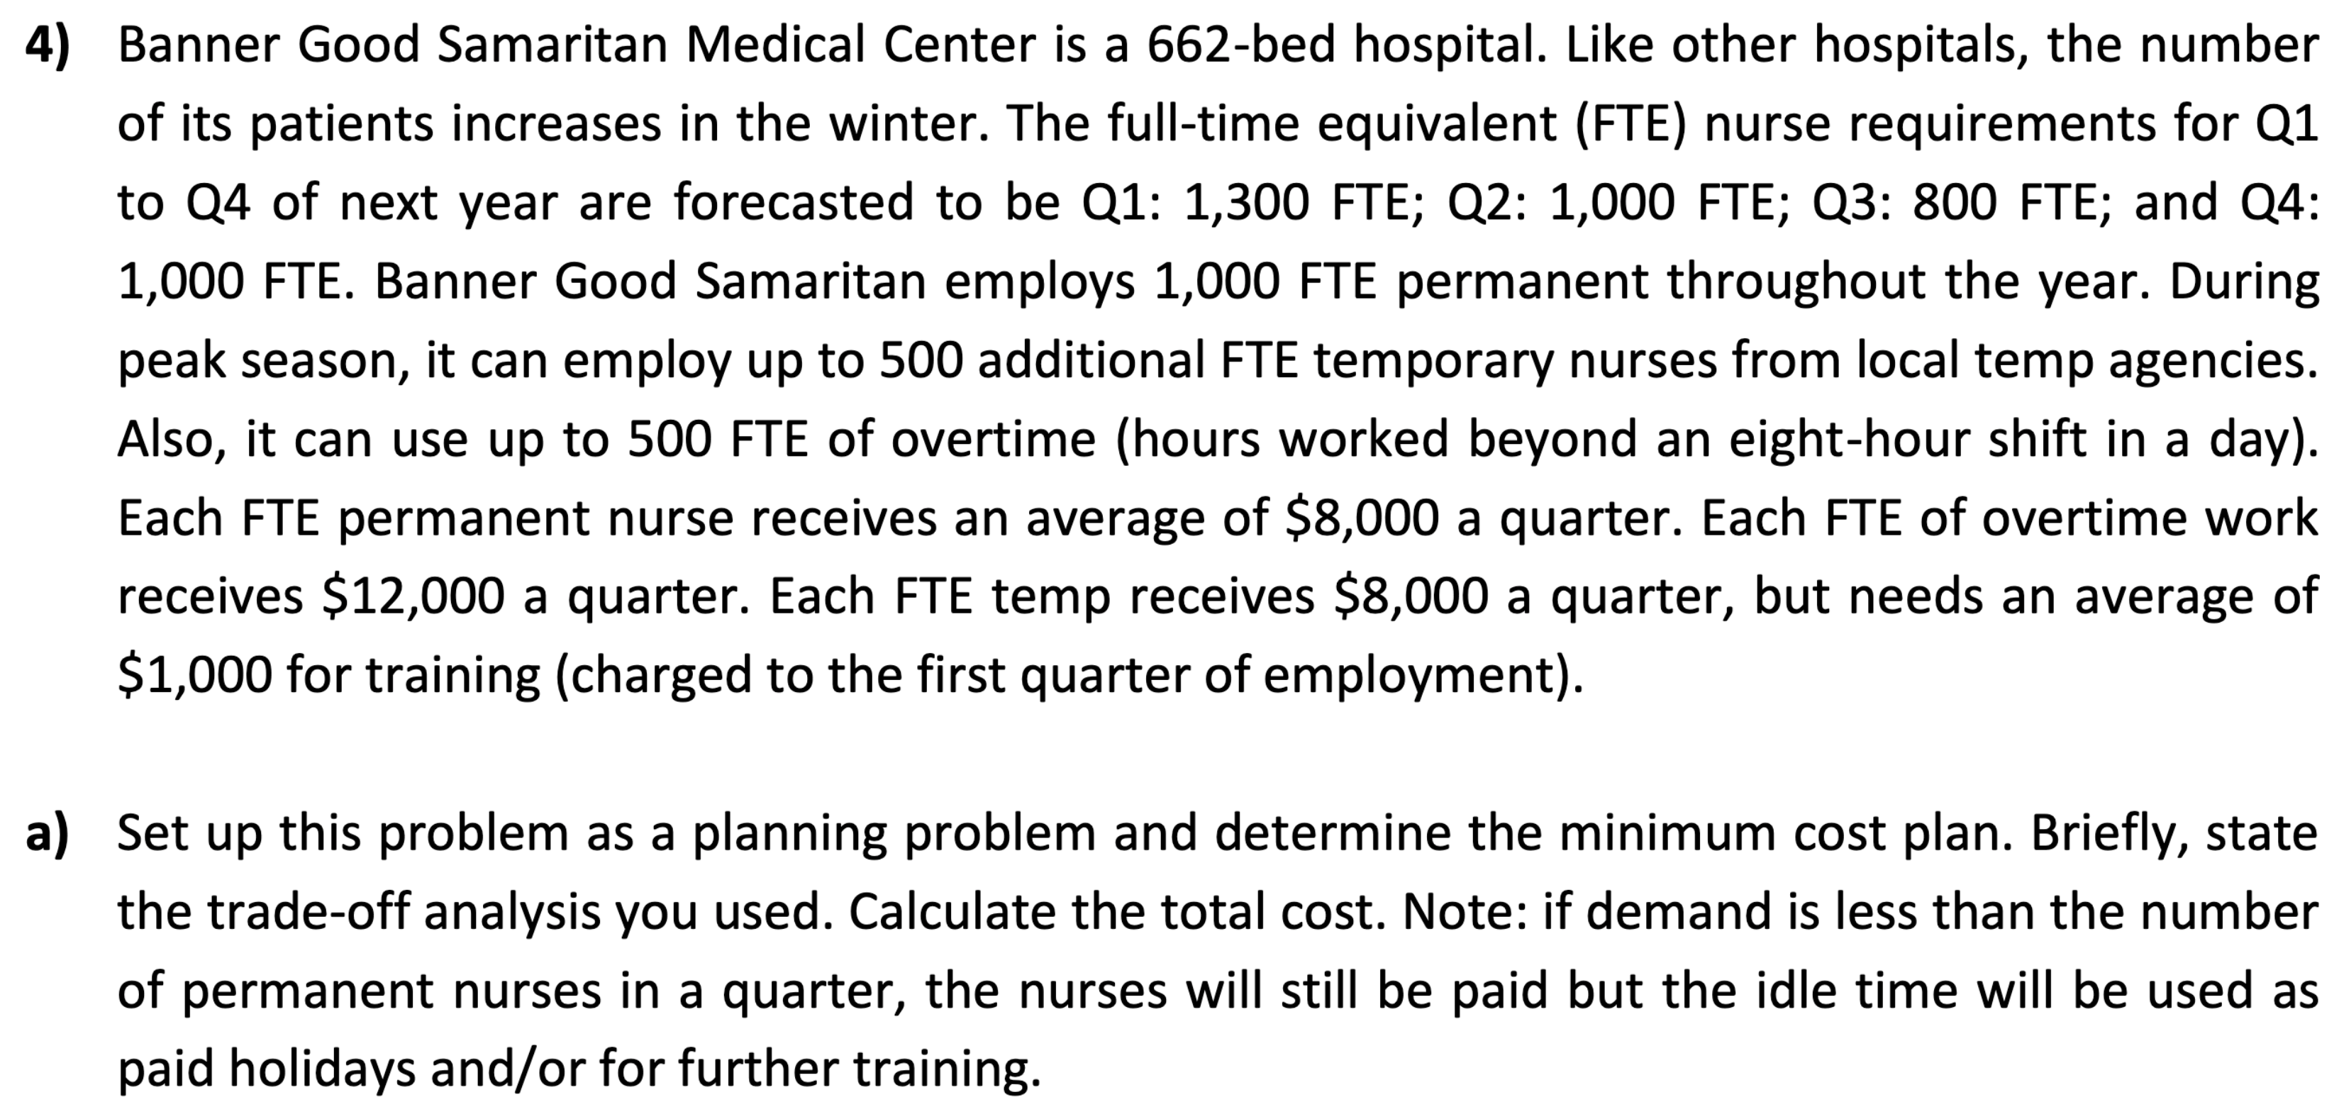

Total cost using temporary FTEs:

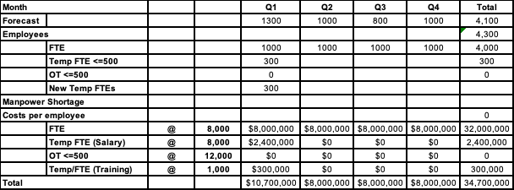

Total cost using overtime:

